

**________________________________________________________________**

**UNIVERSITY OF PETROLEUM & ENERGY STUDIES**

**School of Engineering Studies**

**Dehradun**

**LABORATORY MANUAL**

**BASIC ELCTRONICS LAB**

**DEPARTMENT: ELECTRONICS& INSTRUMENTATION ENGINEERING**

**Every student inside the laboratory should follow the following rules.**

GENERAL INSTRUCTIONS

1. Previous experiment write up should be brought to the lab and submit to the in-charge. Without it they will not be allowed to perform next experiment and will be marked absent.

2. They have to attend the lab in time. Anybody coming late more than 5 minutes will be marked absent for that day.

3. They cannot leave the labs without the permission of the in-charge. Any body found violating the rules would be marked absent.

4. The instrument allotted to a particular group of students, and if it is found not functioning properly after they return the blame will go to the whole group. So they should check the instruments before and after delivery.

5. Students are required to maintain the decorum of the labs

|  |  |
| --- | --- |
| S. NO. | NAME OF EXPERIMENT |
| 1. | To study the various electronics components (diode, resistor, transistor, capacitors, IC’s etc.) and measuring instruments (multimeter, CRO,DSO etc.) |
| 2. | To Study and plot the V-I characteristics of P-N Junction diode and Zener Diode |
| 3. | To Study and set up a half wave and full wave rectifier circuit. And to calculate its form factor, Ripple factor and efficiency |
| 4. | To Study clipper and clamper circuits and plot the wave from |
| 5. | Study of transistor characteristics common emitter (NPN) or (PNP). |
| 6. | Study of transistor characteristics common base (NPN) or (PNP). |
| 7. | Study of logic gates and to verify the truth table |
| 8. | Implementation of AND, OR, NOT Gate using NAND & NOR(Universal gates) |
| 9. | Implementation of half and full adder digital circuits. |
| 10. | Implementation of half and full substractor digital circuits. |

**LIST OF EXPERIMENTS**

**EXPERIMENT NO-1**

**TO STUDY THE VARIOUS ELECTRONICS COMPONENTS (DIODE, RESISTOR, TRANSISTOR, CAPACITORS, IC’S ETC.) AND MEASURING INSTRUMENTS (MULTIMETER, CRO, DSO ETC.)**

**Aim:To study the various electronics components (diode, resistor, transistor, capacitors, IC’s etc.) and measuring instruments (multimeter, CRO,DSO etc.)**

**Introduction-**An electronic circuit is composed of various types of components. Some of these components are termed as active components because they take part in the transformation of the energy while other components, which only dissipate or store energy, are called as passive elements. The vacuum tubes, rectifier, transistors are some of-the common active while the resistances, which dissipate the power and energy storing elements such as capacitances and inductances are known as passive elements. The transformers may be regarded as a matching device. The success of any electronic circuit depends not only on proper selection of the active elements but on the passive and matching elements too. The proper function, of an active device is decided by the proper values of these passive elements. Hence the selection of these elements such as resistances, inductances, capacitance, and transformers not only require the proper attention, but also decide the proper function of the active devices as well as the circuit as a whole.

Here we shall discuss about some important electronic components and their characteristics, particularly used in biomedical instruments.

**Electronics components:** These can be classified into

(I)-**Active Components**

(II)- **Passive Components**

**(I)-Active Components:** They can be further classified as**-**Semiconductor Devices: Semiconductor diode, zener diode, and varactor diode etc. Uni-junction transistor, Bipolar junction transistor (BJT), FET, silicon, Controlled rectifier etc.

**Vacuum Tube Devices:** Vacuum tube diode, triode, Tetrode, Pentode, Hexode, Heptode etc.

**Gas Tube Devices:** Gas diodes, Threatens etc.

**Photo Sensitivity Devices:** Gas photodiodes, photo multiplier tubes, photodiodes, light emitting diode, photosensitive transistor etc.

Though there are devices, which are specific to particular frequency range and applications like microwave devices etc.

**(II)Passive Components:** Components like resistance, capacitanceinductance, and fall in this class.

**Resistor**

A resistor is an electronics/electrical component that limits or regulates the flow of electrical current in an electronic circuit. Resistors can also be used to provide a specific voltage for an active device such as a transistor. All other factors being equal, in a direct-current (DC) circuit, the current through a resistor is inversely proportional to its resistance, and directly proportional to the voltage across it. This is the well-known Ohm's Law. In alternating-current (AC) circuits, this rule also applies as long as the resistor does not contain inductance or capacitance. Resistors can be made to control the flow of current, to work as Voltage dividers, to dissipate power and it can shape electrical waves when used in combination of other components. Basic unit is ohms, (Ω).

**(A)-Carbon-composition resistor**

Resistors can be fabricated in a variety of ways. The most common type in electronic devices and systems is the carbon-composition resistor. Fine granulated carbon (graphite) is mixed with clay and hardened. The resistance depends on the proportion of carbon to clay; the higher this ratio, the lower the resistance.

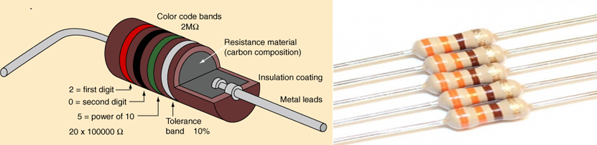

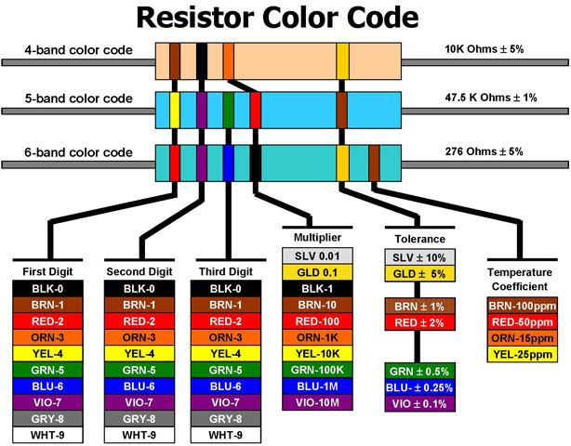

#### 3Band Description

The number of bands is important because the decoding changes based upon the number of color bands. There are three common types: 3 band, 4 band, 5 band, and 6 band resistors. For the 3 band resistor:

**Band 1** – First significant digit.  
**Band 2** – Second significant digit  
**Band 3** – Multiplier

#### 4 Band Description

The number of bands is important because the decoding changes based upon the number of color bands. There are three common types: 4 band, 5 band, and 6 band resistors. For the 4 band resistor:

**Band 1** – First significant digit.  
**Band 2** – Second significant digit  
**Band 3** – Multiplier  
**Band 4** – Tolerance

#### 5 Band Description

The number of bands is important because the decoding changes based upon the number of color bands. There are three common types: 4 band, 5 band, and 6 band resistors. For the 5 band resistor:

**Band 1** – First significant digit.  
**Band 2** – Second significant digit  
**Band 3** – Third significant digit  
**Band 4** – Multiplier  
**Band 5** – Tolerance

#### 6 Band Description

The number of bands is important because the decoding changes based upon the number of color bands. There are three common types: 4 band, 5 band, and 6 band resistors. For the 6 band resistor:

**Band 1** – first significant digit.  
**Band 2** – second significant digit  
**Band 3** – third significant digit  
**Band 4** – Multiplier  
**Band 5** – Tolerance  
**Band 6** – Temperature Coefficient (Tempco)

**(B)-POTENTIOMETER-** Apotentiometer, informally a pot, is a three-terminal resistor with a sliding or rotating contact that forms an adjustable voltage divider. If only two terminals are used, one end and the wiper, it acts as a variable resistor or rheostat.The measuring instrument called a potentiometer is essentially a voltage divider used for measuring electric potential (voltage); the component is an implementation of the same principle, hence its name.Potentiometers are commonly used to control electrical devices such as volume controls on audio equipment. Potentiometers operated by a mechanism can be used as position transducers, for example, in a joystick. Potentiometers are rarely used to directly control significant power (more than a watt), since the power dissipated in the potentiometer would be comparable to the power in the controlled load.

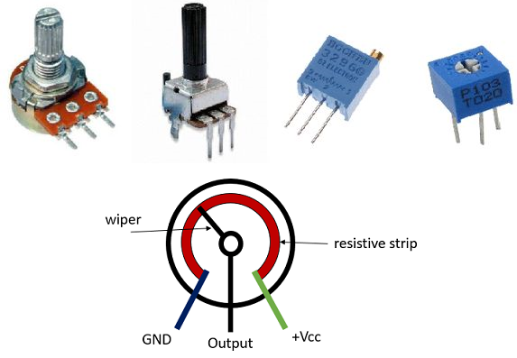

**Capacitors**

The comparisons between the different types of capacitor is generally made with regards to the dielectric used between the plates. Like resistors, there are also variable types of capacitors which allow us to vary their capacitance value for use in radio or “frequency tuning” type circuits. Commercial types of capacitors are made from metallic foil interlaced with thin sheets of either paraffin-impregnated paper or Mylar as the dielectric material. Some capacitors look like tubes, this is because the metal foil plates are rolled up into a cylinder to form a small package with the insulating dielectric material sandwiched in between them. Small capacitors are often constructed from ceramic materials and then dipped into an epoxy resin to seal them. Either way, capacitors play an important part in electronic circuits so here are a few of the more “common” types of capacitor available.

**(A)-Dielectric Capacitor** -**Dielectric Capacitors** are usually of the variable type were a continuous variation of capacitance is required for tuning transmitters, receivers and transistor radios. Variable dielectric capacitors are multi-plate air-spaced types that have a set of fixed plates (the stator vanes) and a set of movable plates (the rotor vanes) which move in between the fixed plates. The position of the moving plates with respect to the fixed plates determines the overall capacitance value. The capacitance is generally at maximum when the two sets of plates are fully meshed together. High voltage type tuning capacitors have relatively large spacing’s or air-gaps between the plates with breakdown voltages reaching many thousands of volts.

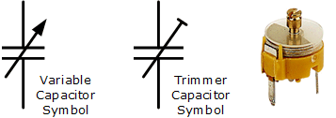

Variable Capacitor

As well as the continuously variable types, preset type variable capacitors are also available called **Trimmers**. These are generally small devices that can be adjusted or “pre-set” to a particular capacitance value with the aid of a small screwdriver and are available in very small capacitance’s of 500pF or less and are non-polarized.

**(B)-Film Capacitor-Film Capacitors** are the most commonly available of all types of capacitors, consisting of a relatively large family of capacitors with the difference being in their dielectric properties. These include polyester (Mylar), polystyrene, polypropylene, polycarbonate, metalized paper, Teflon etc. Film type capacitors are available in capacitance ranges from as small as 5pF to as large as 100uF depending upon the actual type of capacitor and its voltage rating. Film capacitors also come in an assortment of shapes and case styles which include:

* Wrap & Fill (Oval & Round)  –  where the capacitor is wrapped in a tight plastic tape and have the ends filled with epoxy to seal them.
* Epoxy Case (Rectangular & Round)  –  where the capacitor is encased in a molded plastic shell which is then filled with epoxy.
* Metal Hermetically Sealed (Rectangular & Round)  –  where the capacitor is encased in a metal tube or can and again sealed with epoxy. With all the above case styles available in both Axial and Radial Leads.

**Film Capacitors** which use polystyrene, polycarbonate or Teflon as their dielectrics are sometimes called “Plastic capacitors”. The construction of plastic film capacitors is similar to that for paper film capacitors but use a plastic film instead of paper. The main advantage of plastic film capacitors compared to impregnated-paper types is that they operate well under conditions of high temperature, have smaller tolerances, a very long service life and high reliability. Examples of film capacitors are the rectangular metalized film and cylindrical film & foil types as shown below.

### Radial Lead Type

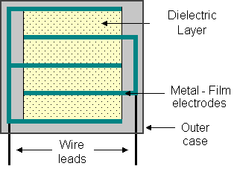

**Axial Lead Type**

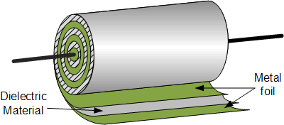

The film and foil types of capacitors are made from long thin strips of thin metal foil with the dielectric material sandwiched together which are wound into a tight roll and then sealed in paper or metal tubes.

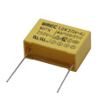

**Film Capacitor**

These film types require a much thicker dielectric film to reduce the risk of tears or punctures in the film, and is therefore more suited to lower capacitance values and larger case sizes.

Metalised foil capacitors have the conductive film metalised sprayed directly onto each side of the dielectric which gives the capacitor self-healing properties and can therefore use much thinner dielectric films. This allows for higher capacitance values and smaller case sizes for a given capacitance. Film and foil capacitors are generally used for higher power and more precise applications.

**(C)-Ceramic Capacitors-Ceramic Capacitors or Disc Capacitors** as they are generally called, are made by coating two sides of a small porcelain or ceramic disc with silver and are then stacked together to make a capacitor. For very low capacitance values a single ceramic disc of about 3-6mm is used. Ceramic capacitors have a high dielectric constant (High-K) and are available so that relatively high capacitance’s can be obtained in a small physical size.

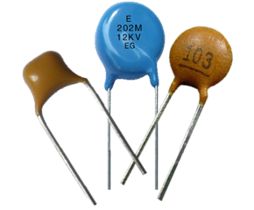

**Ceramic Capacitor**

They exhibit large non-linear changes in capacitance against temperature and as a result are used as de-coupling or by-pass capacitors as they are also non-polarized devices. Ceramic capacitors have values ranging from a few Pico farads to one or two microfarads, (μF) but their voltage ratings are generally quite low.

Ceramic types of capacitors generally have a 3-digit code printed onto their body to identify their capacitance value in Pico-farads. Generally the first two digits indicate the capacitors value and the third digit indicates the number of zero’s to be added. For example, a ceramic disc capacitor with the markings 103 would indicate 10 and 3 zero’s in Pico farads which is equivalent to 10,000 pF or 10nF.Likewise, the digits 104 would indicate 10 and 4 zero’s in Pico farads which is equivalent to 100,000 pF or 100nF and so on. So on the image of the ceramic capacitor above the numbers 154 indicate 15 and 4 zero’s in Pico farads which is equivalent to 150,000 pF or 150nF or 0.15uF. Letter codes are sometimes used to indicate their tolerance value such as: J = 5%, K = 10% or M = 20% etc.

**(D)-Electrolytic Capacitors-Electrolytic capacitors** are generally used when very large capacitance values are required. Here instead of using a very thin metallic film layer for one of the electrodes, a semi-liquid electrolyte solution in the form of a jelly or paste is used which serves as the second electrode (usually the cathode).The dielectric is a very thin layer of oxide which is grown electro-chemically in production with the thickness of the film being less than ten microns. This insulating layer is so thin that it is possible to make capacitors with a large value of capacitance for a small physical size as the distance between the plates, d is very small.

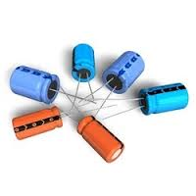**Electrolytic Capacitor**

The majority of electrolytic types of capacitors are Polarized, that is the DC voltage applied to the capacitor terminals must be of the correct polarity, i.e. positive to the positive terminal and negative to the negative terminal as an incorrect polarization will break down the insulating oxide layer and permanent damage may result.

All polarized electrolytic capacitors have their polarity clearly marked with a negative sign to indicate the negative terminal and this polarity must be followed.

**Electrolytic Capacitors** are generally used in DC power supply circuits due to their large capacitance’s and small size to help reduce the ripple voltage or for coupling and decoupling applications. One main disadvantage of electrolytic capacitors is their relatively low voltage rating and due to the polarization of electrolytic capacitors, it follows then that they must not be used on AC supplies. Electrolytic generally come in two basic forms; **Aluminum Electrolytic Capacitors**and**Tantalum Electrolytic Capacitors.**

### Electrolytic Capacitor

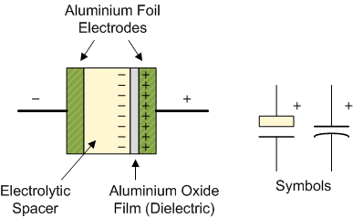

**Inductors-**

Like capacitors, inductors also store energy in one part of AC cycle and return it during the next part of the cycle. Inductance is that property of a device that reacts against a change in current through the device. Inductors are components designed for use in circuits to resist changes in current and thus serve important control functions. Inductor designed is based on the principle that a varying magnetic field induces a voltage in any conductor in that field. Thus, a practical inductor may simply be a coil wire. The current in each loop of the coil produces a magnetic field that passes through neighboring loops. If the current through the coil is constant the magnetic field is constant and no action takes place. A change in the current, however, 8 produces a change in the magnetic field. The energy absorbed or released

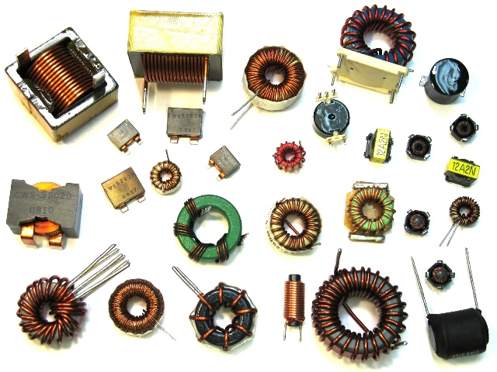

from the changing magnetic field reacts against the change in current, and this is exhibited as in induced voltage (electromotive force, Emf), which is counter to the change in applied voltage. The inductor thus behaves as an impedance to ac current. The counter emf is directly proportional to the rate of change of current through the coil (VL=L[di/dt]). The proportionality constant is the inductance L, which has the unit of henrys (H) in an A.C circuit, as shown in, the inductor offers reactance to alternating current. The inductive reactance XL has the units of ohms and is given by XL = wL = 2πfL Total inductance L = L1 + L2 + L3 ----------- Inductances in parallel: 1/L = 1/L1 + 1/L2 + 1/L3

**Diode**

A diode is a specialized electronic component with two electrodes called the anode and thecathode. Most diodes are made with semiconductor materials such as silicon, germanium, or selenium. Some diodes are comprised of metal electrodes in a chamber evacuated or filled with a pure elemental gas at low pressure. Diodes can be used as rectifiers, signal limiters, voltage regulators, switches, signal modulators, signal mixers, signal demodulators, and oscillators.

### (A)- P_N junction silicon diode

**P-N junction diode** is the most fundamental and the simplest electronics device. When one side of an [intrinsic semiconductor](https://www.electrical4u.com/intrinsic-silicon-and-extrinsic-silicon/) is doped with acceptor i.e., one side is made p-type by doping with n-type material, a p-n junction diode is formed. This is a two terminal device. It appeared in 1950’s. **P-N junction** can be step graded or linearly graded. In step graded the concentration of dopants both, in n - side and in p - side are constant up to the junction. But in linearly graded junction, the doping concentration varies almost linearly with the distance from the junction.

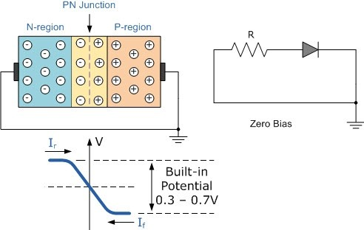

When the **P-N diode** is in unbiased condition that is no [voltage](https://www.electrical4u.com/voltage-or-electric-potential-difference/) is applied across it, electrons will defuse through the junction to p-side and holes will defuse through the junction to n-side and they combine with each other. Thus the acceptor atom near the p-side and donor atom near n-side are left unutilized. An electron field is generated by these uncovered charges. This opposes further diffusion of carriers. So, no movement of region is known as space charge or depletion region.

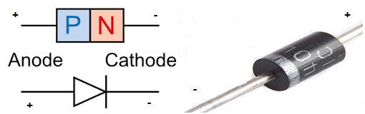

If, we apply forwards bias to the **p-n junction diode**. That means if positive side of the battery is connected to the p – side, then the depletion regions width decreases and carriers flow across the junction. If the bias is reversed the depletion width increases and no charge can flow across the junction.

### (B)-Zener Diode

A zener diode is like a normal diode, but instead of being destroyed by a big reverse voltage, it lets electricity through. The voltage needed for this is called the breakdown voltage or Zener voltage. Because it is built with a known breakdown voltage it can be used supply a known voltage.

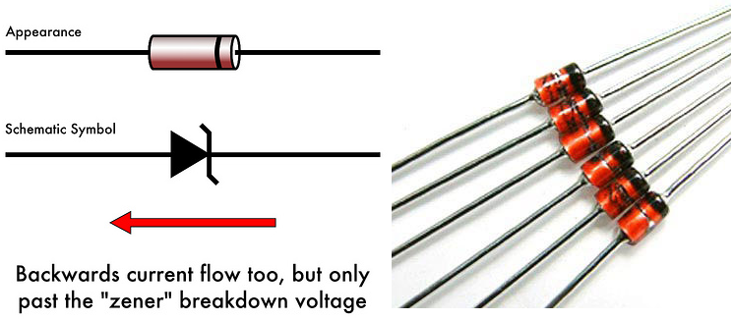

### (C)-Light-Emitting Diode (LED)

An LED produces light when electricity flows through it. It is a longer lasting and more efficient way of creating light than incandescent light bulbs. Depending on how it was made, the LED can make different colors. LEDs were first used in the 1970's. The light-emitting diode may eventually replace the light bulb as developing technology makes it brighter and cheaper (it is already more efficient and lasts longer). In the 1970's the LEDs were used to show numbers in appliances such as calculators, and as a way to show the power was on for larger appliances.

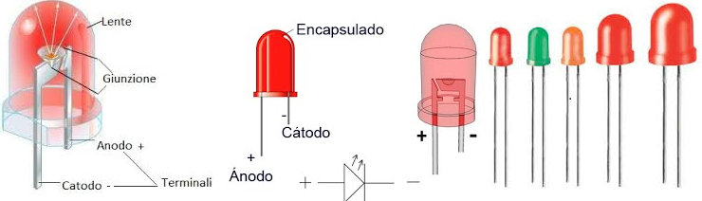

### (D)-Photo diode

A photodiode is a photo detector (the opposite of a light-emitting diode). It responds to light that comes in. Photodiodes have a window or optical fiber connection, which lets light in to the sensitive part of the diode. Diodes usually have strong resistance; the light reduces the resistance.

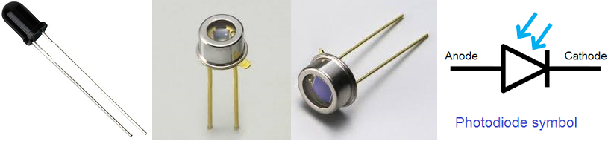

### Voltage Regulator IC (78XX & 78XX)

**A voltage regulator** is one of the most widely used electronic circuitry in any device. A regulated voltage (without fluctuations & noise levels) is very important for the smooth functioning of many digital electronic devices. A common case is with micro controllers, where a smooth regulated input voltage must be supplied for the micro controller to function smoothly

## Nomenclature and packaging

For ICs within the 78xx family, the xx is replaced with two digits, indicating the output [voltage](https://en.wikipedia.org/wiki/Voltage) (for example, the 7805 has a 5-volt output, while the 7812 produces 12 volts). The 78xx line are positive voltage regulators: they produce a voltage that is positive relative to a common ground. There is a related line of **79xx** devices which are complementary negative voltage regulators. 78xx and 79xx ICs can be used in combination to provide positive and negative supply voltages in the same circuit.[[1]](https://en.wikipedia.org/wiki/78xx#cite_note-Rashid2011-1)

78xx ICs have three terminals and are commonly found in the TO-220 form factor, although they are available in surface-mount, TO-92, and TO-3 packages. These devices support an input voltage anywhere from around 2.5 volts over the intended output voltage up to a maximum of 35 to 40 volts depending on the model, and typically provide 1 or 1.5 amperes of current (though smaller or larger packages may have a lower or higher current rating)

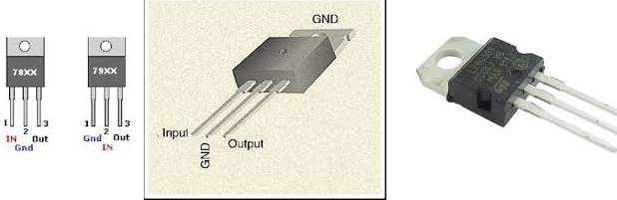

**Family members**

### 78xx

There are common configurations for 78xx ICs, including 7805 (5 V), 7806 (6 V), 7808 (8 V), 7809 (9 V), 7810 (10 V), 7812 (12 V), 7815 (15 V), 7818 (18 V), and 7824 (24 V) versions. The 7805 is the most common, as its regulated 5-volt supply provides a convenient power source for most TTL components.

Less common are lower-power versions such as the LM78Mxx series (500 mA) and LM78Lxx series (100 mA) from National Semiconductor. Some devices provide slightly different voltages than usual, such as the LM78L62 (6.2 volts) and LM78L82 (8.2 volts) as well as the STMicroelectronics L78L33ACZ (3.3 volts).

**Transistors**

Transistor is a semiconductor device which is used to amplify the signals as well as in switching circuits. Generally transistor is made of solid material which contains three terminals such as emitter (E), Base (B) and Collector (C) for connections with other components in the circuit. Some transistors contains fourth terminal also i.e. substrate (S). Transistor is one of the active components. From the time of first transistor invention to present days the transistors are classified into different types depending on either construction or operation, they are explained using tree diagram as below.

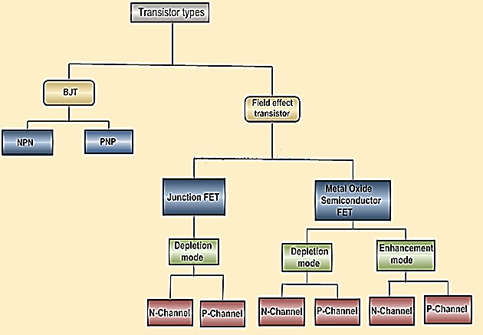

The transistors classification can be understood by observing the above tree diagram. Transistors are basically classified into two types; they are Bipolar Junction Transistors (BJT) and Field Effect Transistors (FET). The BJTs are again classified into NPN and PNP transistors. The FET transistors are classified into JFET and MOSFET. Junction FET transistors are classified into N-channel JFET and P-channel JFET depending on their function. MOSFET transistors are classified into Depletion mode and Enhancement mode. Again depletion and enhancement mode transistors are classified into N-channel JFET and P-channel.

Nowadays the vacuum tubes are replaced with transistors because the transistors have more benefits over vacuum tubes. Transistors are small in size and it requires low voltage for operation and also it has low power dissipation. Due to these reasons the transistor is used in many applications such as amplifiers, switching circuits, oscillators and also in almost all electronic circuits.

### ****Types of Transistors****

Transistor is the proper arrangement of different semiconductor materials. General semiconductor materials used for transistor are silicon, germanium, and gallium-arsenide. Basically the transistors are classified depending on their structure. Each type of transistors has their own characteristics, advantages and disadvantages.Some transistors are designed primarily for switching purpose, other side some are designed for amplification purpose and some transistors are designed for both amplification and switching purposes. Depending on the structure the transistors are classified into BJT and FET.

**Junction Transistors-**

Junction transistor is generally called as Bipolar Junction Transistor (BJT). The BJT transistors have three terminals named emitter (E), Base (B), Collector (C). The name itself indicates that it has two junctions between p-type and n-type semiconductors. The BJT transistors are classified in to NPN and PNP transistors depending on the construction.Unlike FET transistors, the BJT transistors are current-controlled devices. If small amount of current flows through the base of a BJT transistor then it causes to flow large current from emitter to collector. The BJT transistors have low input impedance and it causes to flow large current through the transistor. The BJT transistors are only the transistors which are turned ON by the input current which is given to the base. Bipolar junction transistors can operate in three regions, they are

* **Cut-off Region:** Here the transistor is in ‘OFF’ state i.e the current flowing through the transistor is zero.
* **Active Region:** Here the transistor acts as an amplifier.
* **Saturation Region:** Here the transistor is in fully ‘ON’ state and also works as a closed switch.

#### NPN Transistor

NPN is one of the two types of Bipolar Junction Transistors (BJT). The NPN transistor consists of two n-type semiconductor materials and they are separated by a thin layer of p-type semiconductor. Here the majority charge carriers are electrons and holes are the minority charge carriers. The flowing of electrons from emitter to collector forms the current flow in the transistor through the base terminal. A small amount of current at base terminal causes to flow large amount current from emitter to collector. Nowadays the generally used bipolar transistor is NPN transistor, because the mobility of electrons is greater than mobility of holes. The standard equation for the currents flowing in the transistor is

IE = IB + IC

The symbols and structure for NPN transistors are given below.

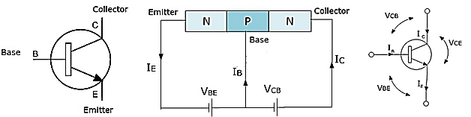

#### PNP Transistor

The PNP is another type of Bipolar Junction Transistors (BJT). The PNP transistors contain two p-type semiconductor materials and are separated by a thin layer of n-type semiconductor. The majority charge carriers in the PNP transistors are holes and electrons are minority charge carriers. The arrow in the emitter terminal of transistor indicates the flow of conventional current. In PNP transistor the current flows from Emitter to Collector. The PNP transistor is ON when the base terminal is pulled to LOW with respect to emitter. The symbol and structure for PNP transistor is shown below.

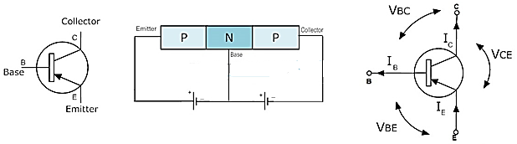

#### ****FET (Field Effect Transistor)****

The Field-Effect-Transistor (FET) is another transistors type. Basically the FET transistors have three terminals they are gate (G), Drain (D) and Source (S). FET transistors are classified into Junction Field Effect transistors (JFET) and Insulated Gate FET (IG-FET) or MOSFET transistors. For the connections in the circuit we also consider fourth terminal called base or substrate. The FET transistors have control on the size and shape of a channel between source and drain which is created by applied voltage. The FET transistors are uni-polar transistors because they perform single channel operation where as BJT transistors are bipolar junction transistors. The FET transistors have high current gain than BJT transistors.

#### JFET (Junction-Field Effect Transistor)

The Junction-Field-Effect transistor (JFET) is an earliest and simple type of FET transistors. These JFETs are used as switches, amplifiers and resistors. This transistor is a voltage controlled device. It doesn’t need any biasing current. The voltage applied between gate and source controls the flow of electric current between source and drain of a transistor. The JFET transistors are available in both N-channel and P-channel types.

#### N-Channel JFET

In N-channel JFET the current flow is due to the electrons. When voltage is applied between gate and source, a channel is formed between source and drain for current flow. This channel is called N-channel. Nowadays N-channel JFET transistor is most preferable type than P-channel JFET. The symbols for N-channel JFET transistor are given below.

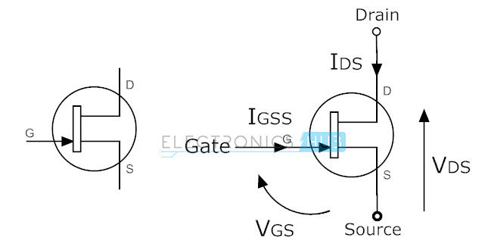

#### P-Channel JFET

In this JFET transistor the current flow is because of holes. The channel between source and drain is called P-channel. The symbols for P-channel JFET transistors are given below. Here arrow marks indicates the direction of current flow.

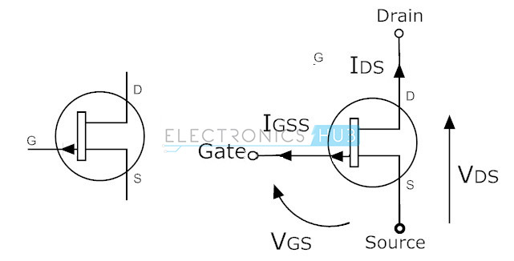

#### ****MOSFET****

Metal-Oxide-Semiconductor Field Effect Transistor (MOSFET) is most useful type of among all transistors. The name itself indicates that it contains metal gate terminal. The MOSFET has four terminals drain, source, gate and body or substrate (B). MOSFET has many advantages over BJT and JFET, mainly it offer high input impedance and low output impedance. It is used in low power circuits mainly in chip designing technologies.The MOSFET transistors are available in depletion and enhancement types. Further the depletion and enhancement types are classified into N-channel and P-channel types.

#### N-Channel MOSFET

The MOSFET having N-channel region between source and drain is called N-channel MOSFET. Here the source and gate terminals are heavily doped with n-type materials and substrate is doped with p-type semiconductor material. Here the current flow between source and drain is because of electrons. The gate voltage controls the current flow in the circuit. N-channel MOSFET is most preferable than P-channel MOSFET because the mobility of electrons is high than mobility of holes. The symbols for N-channel MOSFET transistors are given below.

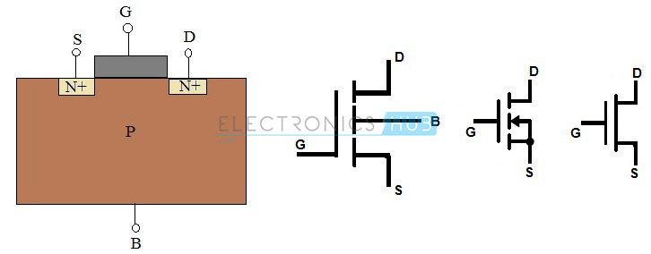

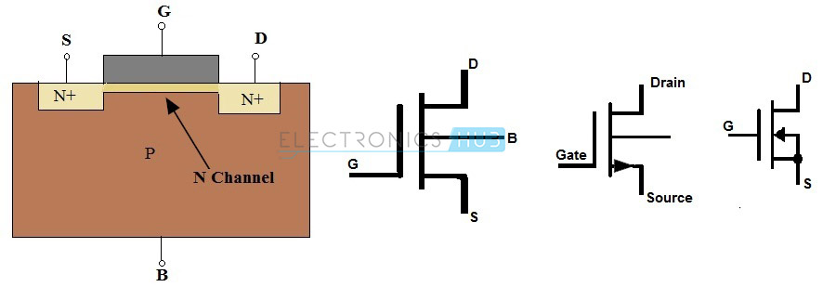

#### P- Channel MOSFET

The MOSFET having P-channel region between source and drain is called as P-channel MOSFET. Here the source and drain terminals are heavily doped with P-type material and the substrate is doped with N-type material. The current flow between source and drain is because of holes concentration. The applied voltage at gate will controls the flow of current through channel region. The symbols for P-channelMOSFET transistors in depletion and enhancement types are given below.

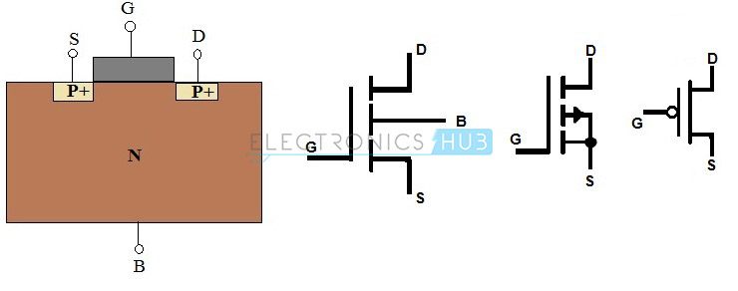

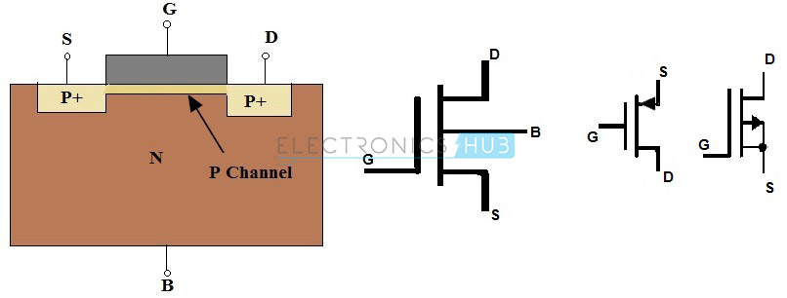

**Digital storage oscilloscope** (DSO)

A **digital storage oscilloscope** (often abbreviated **DSO**) is an oscilloscope which stores and analyses the signal digitally rather than using analog techniques. It is now the most common type of oscilloscope in use because of the advanced trigger, storage, display and measurement features which it typically provides.

The input analogue signal is sampled and then converted into a digital record of the amplitude of the signal at each sample time. The sampling frequency should be not less than the Nyquist rate to avoid aliasing. These digital values are then turned back into an analogue signal for display on a cathode ray tube (CRT), or transformed as needed for the various possible types of output—liquid crystal display, chart recorder, plotter or network interface.

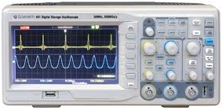

Digital storage oscilloscope

### Cathode-Ray Oscilloscope(CRO)

Cathode-ray oscilloscope (CRO) is a common laboratory instrument that provides accurate time and aplitude measurements of voltage signals over a wide range of frequencies. Its reliability, stability, and ease of operation make it suitable as a general purpose laboratory instrument. The heart of the CRO is a cathode-ray tube

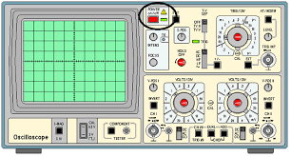

### Cathode-Ray Oscilloscope

**THE BREADBOARD**

The breadboard consists of two terminal strips and two bus strips (often broken in the center). Each bus strip has two rows of contacts. Each of the two rows of contacts are a node. That is, each contact along a row on a bus strip is connected together (inside the breadboard). Bus strips are used primarily for power supply connections, but are also used for any node requiring a large number of connections. Each terminal strip has 60 rows and 5 columns of contacts on each side of the center gap. Each row of 5 contacts is a node. You will build your circuits on the terminal strips by inserting the leads of circuit components into the contact receptacles and making connections with 22-26 gauge wire. There are wire cutter/strippers and a spool of wire in the lab. It is a good practice to wire +5V and 0V power supply connections to separate bus strips.

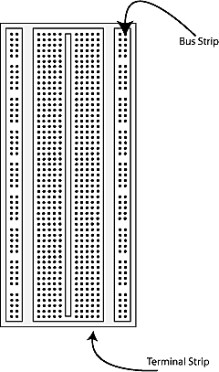

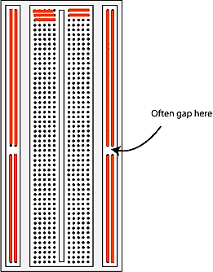

**The lines indicate connected holes.**

 The 5V supply **MUST NOT BE EXCEEDED** since this will damage the ICs (Integrated circuits) used during the experiments. Incorrect connection of power to the ICs could result in them exploding or becoming very hot - with the possible serious injury occurring to the people working on the experiment! Ensure that the power supply polarity and all components and connections are correct before switching on power Supply.

**Building the Circuit**

Throughout these experiments we will use TTL chips to build circuits. The steps for wiring a circuit should be completed in the order described below:

|  |
| --- |
| 1. Turn the power (Trainer Kit) off before you build anything! |
| 1. Make sure the power is off before you build anything! |
| 1. Connect the +5V and ground (GND) leads of the power supply to the power and ground bus strips on your breadboard. |
| 1. Plug the chips you will be using into the breadboard. Point all the chips in the same direction with pin 1 at the upper-left corner. (Pin 1 is often identified by a dot or a notch next to it on the chip package) |
| 1. Connect +5V and GND pins of each chip to the power and ground bus strips on the breadboard. |
| 1. Select a connection on your schematic and place a piece of hook-up wire between corresponding pins of the chips on your breadboard. It is better to make the short connections before the longer ones. Mark each connection on your schematic as you go, so as not to try to make the same connection again at a later stage. |
| 1. Get one of your group members to check the connections, **before you turn the power on**. |
| 1. If an error is made and is not spotted before you turn the power on. Turn the power off immediately before you begin to rewire the circuit. |
| 1. At the end of the laboratory session, collect you hook-up wires, chips and all equipment and return them to the demonstrator. |
| 1. Tidy the area that you were working in and leave it in the same condition as it was before you started. |

**Common Causes of Problems**

|  |
| --- |
| 1. Not connecting the ground and/or power pins for all chips. |
| 1. Not turning on the power supply before checking the operation of the circuit. |
| 1. Leaving out wires. |
| 1. Plugging wires into the wrong holes. |
| 1. Driving a single gate input with the out puts of two or more gates |
| 1. Modifying the circuit with the power on. |

**Multimeter**

A **multimeter**  also known as a **VOM** (volt-ohm-millimeter), is an electronic measuring instrument that combines several measurement functions in one unit. A typical multimeter can measure voltage, current, and resistance. **Analog multimeter** use a micrometer with a moving pointer to display readings. **Digital multimeter** (DMM, DVOM) have a numeric display, and may also show a graphical bar representing the measured value. Digital multimeter are now far more common due to their cost and precision, but analog multimeter are still preferable in some cases, for example when monitoring a rapidly varying value.

A multimeter can be a hand-held device useful for basic fault finding and field service work, or a bench instrument which can measure to a very high degree of accuracy. They can be used to troubleshoot electrical problems in a wide array of industrial and household devices such as electronic equipment, motor controls, domestic appliances, power supplies, and wiring systems.

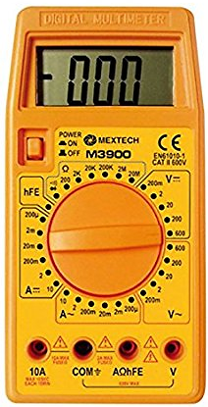

DIGITAL MULTIMETER

**EXPERIMENT NO-2**

**TO STUDY AND PLOT THE V-I**

**CHARACTERISTICS OF P-N**

**JUNCTION**

**DIODE AND ZENER DIODE**

**(A)-CHARACTERISTICS OF Si-DIODE**

**AIM:**To study the PN junction diode characteristics under Forward & Reverse bias conditions.

**APPARATUS REQUIRED**:

|  |  |  |  |  |
| --- | --- | --- | --- | --- |
| **S.No** | **Name** | **Range** | **Type** | **Quantity** |
| **1** | Regulated power supply | (0-30)V | DC | 1 |
| **2** | Ammeter | (0-200) mA (for [Forward](http://www.electrical4u.com/pn-junction/) bias)(0-200)µA (for [Reverse Bias](http://www.electrical4u.com/pn-junction/)) | DC | 1 |
| **3** | Voltmeter | (0-20)V (for [Forward](http://www.electrical4u.com/pn-junction/) bias) (0-30)V(for [Reverse Bias](http://www.electrical4u.com/pn-junction/)) | DC | 1 |
| **4** | Si Diode | 1N4007 |  | 1 |
| **5** | Resistor | 1KΩ |  | 1 |
| **6** | Breadboard |  |  | 1 |
| **7** | Wires |  |  |  |

**THEORY:** A PN junction diode is a two terminal junction device. Itconducts only in one direction (only on forward biasing).

**FORWARD BIAS:** On forward biasing, initially no current flows due to barrier potential. As the applied potential exceeds the barrier potential the charge carriers gain sufficient energy to cross the potential barrier and hence enter the other region. The holes which are majority carriers in the P-region, become minority carriers on entering the N-regions, and electrons, which are the majority carriers in the N-region become minority carriers on entering the P-region.

**REVERSE BIAS:** On reverse biasing, the majority charge carriers are attracted towards the terminals due to the applied potential resulting in the widening of the depletion region. Since the charge carriers are pushed towards the terminals no current flows in the device due to majority charge carriers. There will be some current in the device due to the thermally generated minority carriers. The generation of such carriers is independent of the applied potential and hence the current is constant for all increasingreverse potential. This current is referred to as reverse Saturation Current (IO) and it increases with temperature. When the applied reverse voltage is increased beyond the certain limit, it results in breakdown. During breakdown, the diode current increases tremendously.

CIRCUIT DIAGRAM:

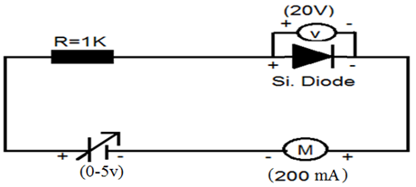

**FORWARD BIAS**

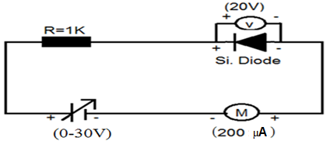

**REVERSE BIAS**

Specification for 1N4001: Silicon Diode

Peak Inverse Voltage: 50V

Idc= 1A.

Maximum forward voltage drop at 1 Amp is 1.1 volts

Maximum reverse current @50 volts is 5µA

**OBSERVATIONS:**

1. Find the d.c (static) resistance = V/I.
2. Find the a.c (dynamic) resistance r = (r = V/I) =V2-V1 / I2-I1
3. .Find the forward voltage drop = [Hint: it is equal to 0.7 for Si and 0.3 forGe.].

**Measurement in forward bias**

|  |  |  |  |
| --- | --- | --- | --- |
| **S. No.** | **Input voltage** | **Diode Voltage(Vd)** | **Current(mA) (Id)** |
| 1.  2.  3  4.  5.  6.  7.  8.  9.  10.  11.  12.  13.  14. | 0.1V  0.2V  0.3V  0.4V  0.5V  0.6V  0.7V  0.8V  0.9V  1 V  2 V  3 V  4 V  5 V |  |  |

**Measurement in reverse bias**

|  |  |  |  |
| --- | --- | --- | --- |
| S.No. | Input Voltage | Diode Voltage (Vd) | Current (µA)(Id) |
| 1. | 2V |  |  |
| 2. | 4V |  |  |
| 3. | 6V |  |  |
| 4. | 8V |  |  |
| 5. | 10V |  |  |
| 6. | 12V |  |  |
| 7. | 14V |  |  |
| 8. | 16V |  |  |
| 9. | 18V |  |  |
| 10. | 20V |  |  |
| 11. | 22V |  |  |
| 12. | 24V |  |  |
| 13. | 26V |  |  |
| 14. | 28V |  |  |
| 15. | 30V |  |  |

**MODEL GRAPH**

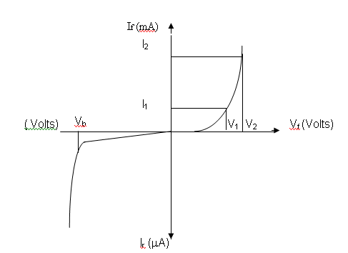

**FORWARD BIAS:**

1. Connect the circuit as per the diagram.

2. Vary the applied voltage V in steps of 0.1V.

3. Note down the corresponding Ammeter readings I.

4. Plot a graph between V & I

**REVERSE BIAS:**

1. Connect the circuit as per the diagram.

2. Vary the applied voltage V in steps of 1.0V.

3. Note down the corresponding Ammeter readings I.

4. Plot a graph between V & I.

### 5. Find the dynamic resistance r = ∆V / ∆I

**RESULT:**

Forward and Reverse bias characteristics of the PN junction diode and the dynamic resistance under

* Forward bias = ---------------------
* Reverse bias = ----------------------.
* Reverse Saturation Current = ----------------.

**PRECAUTIONS:**

1. While doing the experiment do not exceed the ratings of the diode. This may lead to damage of the diode.

2. Connect voltmeter and Ammeter in correct polarities as shown in the circuit diagram.

3. Do not switch ON the power supply unless you have checked the circuit connections as per the circuit diagram

**(B)-CHARACTERISTICS OF ZENER DIODE**

**AIM**: **Plot the V-I Characteristics of Zener Diode in forward and reverse bias condition and to determine the breakdown voltage of a given zener diode**

**APPARATUS REQUIRED:**

|  |  |  |  |  |
| --- | --- | --- | --- | --- |
| **S No** | **Name** | **Range** | **Type** | **Quantity** |
| **1** | **Regulated power supply** | (0-30)V | DC | 1 |
| **2** | **Ammeter** | **(0-200)mA**(for [Forward](http://www.electrical4u.com/pn-junction/) bias  **(0-200)µA**(for Revers bias) | DC | 1 |
| **3** | **Voltmeter** | **(0-20)V**(for [Forward](http://www.electrical4u.com/pn-junction/) bias)  **(0-200)V** (for Revers bias) | DC | 1 |
| **4** | **ZenerDiode** | FZ.6.1 |  | 1 |
| **5** | **Resistor** | 1KΩ |  | 1 |
| **6** | **Breadboard** |  |  | 1 |
| **7** | **Wires** |  |  |  |

**THEORY:** A properly doped crystal diode, which has a sharp breakdown voltage, is known as zener diode.

**FORWARD BIAS:**On forward biasing, initially no current flows due to barrier potential. As the applied potential increases, it exceeds the barrier potential at one value and the charge carriers gain sufficient energy to cross the potential barrier and enter the other region. the holes ,which are majority carriers in p-region, become minority carriers on entering the N-regions and electrons, which are the majority carriers in the N-regions become minority carriers on entering the P-region. This injection of minority carriers results current, opposite to the direction of electron movement.

**REVERSE BIAS:**When the reverse bias is applied due to majority carriers small amount of current (i.e) reverse saturation current flows across the junction. As the reverse bias is increased to breakdown voltage, sudden rise in current takes place due to zener effect.

**ZENER EFFECT:**Normally, PN junction of Zener Diode is heavily doped. Due to heavy doping the depletion layer will be narrow. When the reverse bias is increased the potential across the depletion layer is more. This exerts a force on the electrons in the outermost shell. Because of this force the electrons are pulled away from the parent nuclei and become free electrons. This ionization, which occurs due to electrostatic force of attraction, is known as Zener effect. It results in large number of free carriers, which in turn increases the reverse saturation current.

**FORWARD BIAS:**

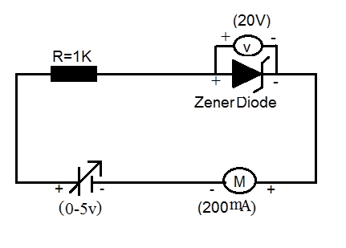

REVERSE BIAS:

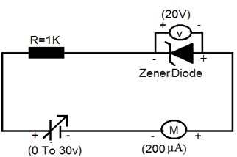

**Measurement in forward bias**

|  |  |  |  |
| --- | --- | --- | --- |
| **S.No.** | **Input voltage** | **Diode Voltage (VD)** | **Current (mA)** |
| **1.**  **2.**  **3.**  **4.**  **5.**  **6.**  **7.**  **8.**  **9.**  **10.**  **11.**  **12.**  **13.**  **14.** | **0.1V**  **0.2V**  **0.3V**  **0.4V**  **0.5V**  **0.6V**  **0.7V**  **0.8V**  **0.9V**  **01V**  **02V**  **03V**  **04V**  **05V** |  |  |

**Measurement in reverse bias**

|  |  |  |  |
| --- | --- | --- | --- |
| **S.No** | **Input Voltage** | **Diode Voltage (Vz)** | **Current (µA)** |
| **1**  **2**  **3**  **4**  **5**  **6**  **7**  **8**  **9**  **10**  **11**  **12**  **13**  **14**  **15** | **1v**  **2v**  **3v**  **4v**  **5v**  **6v**  **7v**  **8v**  **9v**  **10v**  **11v**  **12v**  **13v**  **14v**  **15v** |  |  |

**MODEL GRAPH**

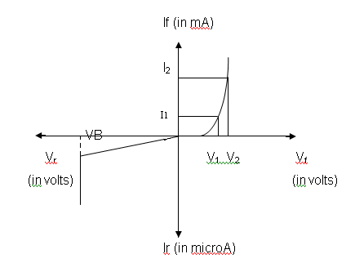

**PROCEDURE:**

**FORWARD BIAS**

1. Connect the circuit as per the circuit diagram.

2 .Vary the power supply in such a way that the readings are taken in steps

of 0.1V in the voltmeter till the needle of power supply shows 30V.

3. Note down the corresponding ammeter readings.

4. Plot the graph V.d .(vs) I.

5. Find the dynamic resistance r = V / I.

**REVERSE BIAS**

1. Connect the circuit as per the diagram.

2. Vary the power supply in such a way that the readings are taken in steps of 0.1V in the voltmeter till the needle of power supply shows 30V.

3. Note down the corresponding Ammeter readings I.

4. Plot a graph between V & I.

5. Find the dynamic resistance r = V / I.

6. Find the reverse voltage Vr at Iz=20 mA.

**RESULT:**

Forward and Reverse bias characteristics of the zener diode was studied and

Forward bias dynamic resistance = ---------------------

Reverse bias dynamic resistance = ----------------------

The reverse voltage at Iz=20 mA determined from the reverse characteristics of the Zener diode is --------------------------.

**EXPERIMENT NO-3**

**TO STUDY AND SET UP A HALF WAVE AND FULL WAVE RECTIFIER CIRCUIT. AND TO CALCULATE ITS FORM FACTOR, RIPPLE FACTOR AND EFFICIENCY**

**(A)-HALF WAVE RECTIFIER**

**AIM:To construct a Half wave rectifier using diode and to draw its performance characteristics**.

**APPARATUS REQUIRED:**

|  |  |  |  |  |
| --- | --- | --- | --- | --- |
| **S No** | **Name** | **Range** | **Type** | **Quantity** |
| **1** | **Transformer** | 230/(9-0-9)V | Step down | 1 |
| **2** | **Diode** | 1N4007 |  | 1 |
| **3** | **Resistor** | 1KΩ |  | 1 |
| **4** | **Breadboard** |  |  | 1 |
| **5** | **Connecting Wires** |  |  |  |
| **6** | **Digital storage oscilloscope(DSO)/Cathode Ray oscilloscope (CRO)** |  |  | 1 |

**THEORY-**A diode is a unidirectional conducting device. It conducts only when its anodes is at cycle of the input, the diode gets forward biased and it conducts .current flows through the load resistor RL and a higher voltage with respect to its cathode. In a half wave rectifier circuit during positive half voltage is developed across it. During negative half cycle of the input, the diode gets reverse biased. Now no current (except the leakage current which is very small) flows. The voltage across the load resistance during this period of input cycle is zero. Thus a pure AC signal is converted into a unidirectional signal. It can be show that

## =

Where,

is the output DC voltage and  is peak AC voltage at the input of rectifier circuit.

220v/6v

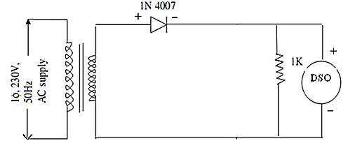**CIRCUIT DIAGRAM FOR HALF WAVE RECTIFIER**

Ripple factor =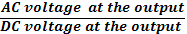

**PROCEDURE:**

**1**. Connect the primary side of the transformer to the AC mains. Connect the CRO/DSO probes to the output points. Adjust the CRO/DSO so that a good and stable wave shape is visible on it screen. Plot this wave form in your record book. Take the CRO/DSO probes at the input points of the rectifier. Note the wave shape of the signal. Compare them.

**2.** Now use a multi meter to measure the AC voltage at the secondary terminals of the transformer. This given the r.m.s value. Also measure the AC & DC voltage at the output points.

**3.** Multiply this r.m.s value by  to get the peak value. Calculate the theoretical value of DC voltage using formula  = Compare this value with the practically measured value of output DC voltage.

**4.** Using the measured value of DC and AC output voltages calculate ripple factor.

## CALCULATION:

## 1. =

## 2. =

## 3. Form factor =

## 4. Ripple = $\sqrt{{\left(\frac{V_{rms}}{V_{dc}}\right)}^{2}}-1$

**MODEL GRAPH:**

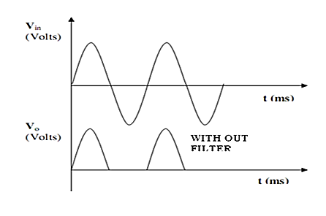

## OBSERVATION:

|  |  |  |
| --- | --- | --- |
|  | **Theoretical value** | **Practical value** |
|  | **-** |  |
|  | **-** |  |
| **Form factor** | **1.57** |  |
| **Ripple factor** | **1.21** |  |

## RESULT: We have studied the half wave rectifier using one diode in forward condition & calculated its ripple factor & form factor.

**(B)-FULL WAVE RECTIFIER**

**AIM:To construct a Full wave rectifier using diode and to draw its performance characteristics.**

**APPARATUS REQUIRED:**

|  |  |  |  |  |
| --- | --- | --- | --- | --- |
| S No | Name | Range | Type | Quantity |
| 1 | Transformer | 230V / (9-0-9)V | AC | 1 |
| 2 | Si Diode | 1N4007 |  | 2 |
| 3 | Resistor | 1KΩ |  | 1 |
| 4 | Breadboard |  |  | 1 |
| 5 | Connecting Wires |  |  |  |
| 6 | Digital storage oscilloscope(DSO)/Cathode Ray oscilloscope (CRO) |  |  | 1 |

## THEORY:-

## In a full wave rectifier circuit there are two diodes, a transformer and a load resistor. The transformer has a center-tap in its secondary winding. It provides out -of –phase voltage to the two diodes. During the positive half cycle of the input, the diode D2 is reverse biased and it does not conduct. But diode D1 is forward biased and it conduct. The current flowing through D1 also passes through the load resistor and a voltage is developed across it. During the negative half cycle, the diode D2 is forward biased and D1 is reverse biased. Now, current flow through diode D2 & load resistor. The current flowing through load resistor RL passes in the same direction in both the half cycles. The DC voltage obtained at the output is given as

# 

Where, is the peak value of the AC voltage between the centre-tap point and one of the diode.

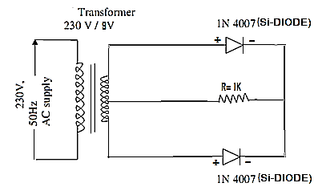

**Circuit diagram for full wave rectifier**

##### **PROCEDURE:**

##### **1**. Connect the mains voltage to the primary of the center – tapped transformer. Connect the output terminals to the CRO/DSO. Adjust the CRO/DSO at the center –tap and one of the diode. Observe the wave shape on the CRO/DSO. Plot both the wave shape in your record book. Compare the two voltage wave shapes.

2. Measure AC voltage at the input and output points. Also measure the DC voltage across the load resistor.

3. from the measured AC voltage. Calculate the DC voltage. Compare it with the measured value of DC output voltage. Now calculate the ripple factor by dividing AC voltage (at the output) by DC voltage at the output.

## CALCULATION:

## 

## 

# 3. Form factor =

## 4. Ripple factor =

**MODEL GRAPH**

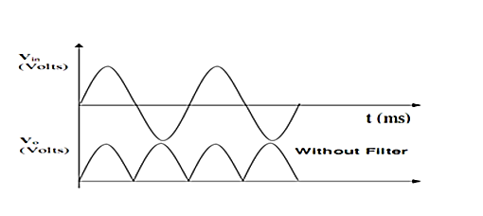

## OBSERVATION:

|  |  |  |
| --- | --- | --- |
|  | **Theoretical value** | **Practical value** |
|  | **-** |  |
|  | **-** |  |
| **Form factor** | **1.11** |  |
| **Ripple factor** | **0.48** |  |

## RESULT:We have studied the full wave rectifier circuit using two diode in forward condition & calculated its ripple factor & form factor.

**(C)-BRIDGE RECTIFIER**

**AIM:To construct a bridge rectifier using diode and to draw its performance characteristics**.

**APPARATUS REQUIRED:**

|  |  |  |  |  |
| --- | --- | --- | --- | --- |
| **S No** | **Name** | **Range** | **Type** | **Quantity** |
| **1** | **Transformer** | **230V / (9-0-9)V** | AC | 1 |
| **2** | **Si Diode** | 1N4007 |  | 4 |
| **3** | **Resistor** | 1KΩ |  | 1 |
| **4** | **Breadboard** |  |  | 1 |
| **5** | **Connecting Wires** |  |  |  |
| **6** | **Digital storage oscilloscope(DSO)/Cathode Ray oscilloscope (CRO)** |  |  | 1 |

## THEORY:

In a Bridge rectifier circuit there are four diodes, a transformer and a load resistor. When the input voltage is positive at point A diode and  conduct. The current passes through the load resistor .during the other half cycle of the input signal. The point A is negative with respect to the point B. the diode and conduct. The current passes through the load resistor in the same direction as during the positive half cycle. DC voltage is developed across the load. It can be proved that the output DC voltage is given by

# 

Where is the peak AC voltage at the input of the rectifier.

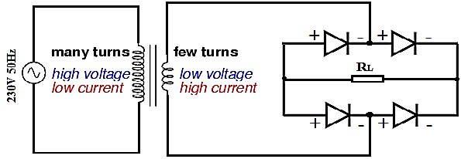

**Circuit diagram of bridge rectifier**

## PROCEDURE:

**1**. Energize the rectifier with the AC mains. Connect the output of the rectifier to the CRO/DSO. Adjust the CRO/DSO till you get a stable pattern on the rectifier. Compare the two wave shapes.

**2.** Now measure the AC voltage at the secondary of the transformer. Also measure AC & DC voltage at the output points

**3.** Using the theoretical formula -

# 

Calculate the DC voltage at the output. Compare this value with the measured DC voltage. Use the measured values of AC & DC voltage at the output points. To calculate the ripple factor Compare this value with the theoretical value.

## CALCULATION:

1. 

2. 

3. Form factor = 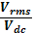

4. Ripple factor = 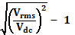

## OBSERVATION:

|  |  |  |
| --- | --- | --- |
|  | **Theoretical value** | **Practical value** |
|  | **-** |  |
|  | **-** |  |
| **Form factor** | **1.11** |  |
| **Ripple factor** | **0.48** |  |

## RESULT:-

We have studied the bridge rectifier & calculate it’s ripple factor & form factor.

**EXPERIMENT NO-4**

**TO STUDY THE CLIPPER AND CLAMPER**

**CIRCUITS AND TO PLOT THE WAVE**

**FROM**

**(A)-CLIPPERS CIRCUITS**

**AIM:To Study various clippers circuits using diodes.**

**APPARATUS REQUIRED:**

|  |  |  |  |  |
| --- | --- | --- | --- | --- |
| S No | Name | Range | Type | Quantity |
| 1 | Digital storage oscilloscope(DSO)/Cathode Ray oscilloscope (CRO) | 40MHz |  | 1 |
| 2 | Regulated power supply | (0-30)V | AC/DC | 2 |
| 3 | Diode (Si Diode) |  | 1N4007 | 1 |
| 4 | Resistor | 1KΩ |  | 1 |
| 5 | Breadboard |  |  | 1 |
| 6 | Function Generator | 1MHz |  | 1 |
| 7 | Wires |  |  |  |

**THEORY:**

The diode clipper, also known as a *Diode Limiter*, is a wave shaping circuit that takes an input waveform and clips or cuts off its top half, bottom half or both halves together. This clipping of the input signal produces an output waveform that resembles a flattened version of the input. For example, the half-wave rectifier is a clipper circuit, since all voltages below zero are eliminated. But Diode Clipping Circuits can be used a variety of applications to modify an input waveform using signal and Scotty diodes or to provide over-voltage protection using zener diodes to ensure that the output voltage never exceeds a certain level protecting the circuit from high voltage spikes. Then diode clipping circuits can be used in voltage limiting applications.

We saw in the signal diode tutorial that when a diode is forward biased it allows current to pass through itself clamping the voltage. When the diode is reverse biased, no current flows through it and the voltage across its terminals is unaffected, and this is the basic operation of the diode clipping circuit.

Although the input voltage to diode clipping circuits can have any waveform shape, we will assume here that the input voltage is sinusoidal. Consider the circuits below.

Related Products:

**(A)-Positive parallel clipper Circuits**

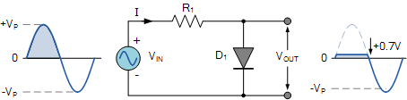

In this diode clipping circuit, the diode is forward biased (anode more positive than cathode) during the positive half cycle of the sinusoidal input waveform. For the diode to become forward biased, it must have the input voltage magnitude greater than +0.7 volts (0.3 volts for a germanium diode).

When this happens the diodes begins to conduct and holds the voltage across itself constant at 0.7V until the sinusoidal waveform falls below this value. Thus the output voltage which is taken across the diode can never exceed 0.7 volts during the positive half cycle.

During the negative half cycle, the diode is reverse biased (cathode more positive than anode) blocking current flow through itself and as a result has no effect on the negative half of the sinusoidal voltage which passes to the load unaltered. Then the diode limits the positive half of the input waveform and is known as a positive clipper circuit.

**(B)-Negative parallel clipper Circuits**

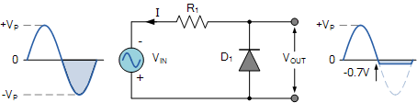

Here the reverse is true. The diode is forward biased during the negative half cycle of the sinusoidal waveform and limits or clips it to -0.7 volts while allowing the positive half cycle to pass unaltered when reverse biased. As the diode limits the negative half cycle of the input voltage it is therefore called a negative clipper circuit.

**Biased Diode Clipping Circuits**

To produce diode clipping circuits for voltage waveforms at different levels, a bias voltage, VBIAS is added in series with the diode as shown. The voltage across the series combination must be greater than VBIAS + 0.7V before the diode becomes sufficiently forward biased to conduct. For example, if the VBIAS level is set at 4.0 volts, then the sinusoidal voltage at the diode’s anode terminal must be greater than **4.0 + 0.7 = 4.7 volts** for it to become forward biased. Any anode voltage levels above this bias point are clipped off.

**(a)-Positive Bias Diode Clipping**

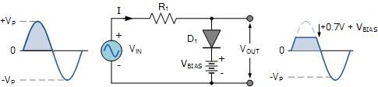

Likewise, by reversing the diode and the battery bias voltage, when a diode conducts the negative half cycle of the output waveform is held to a level -VBIAS – 0.7V as shown.

**(b)-Negative Bias Diode Clipping**

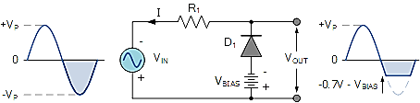

A variable diode clipping or diode limiting level can be achieved by varying the bias voltage of the diodes. If both the positive and the negative half cycles are to be clipped, then two biased clipping diodes are used. But for both positive and negative diode clipping, the bias voltage need not be the same. The positive bias voltage could be at one level, for example 4 volts, and the negative bias voltage at another, for example 6 volts as shown.

## Series clipper

## (a)-Series positive clipper

In series positive clipper, the positive half cycles of the input AC signal is removed. If the diode is arranged in such a way that the arrowhead of the diode points towards the input and the diode is in series with the output load resistance, then the clipper is said to be a series positive clipper. In the circuit diagram, the diode D1 is connected in series with the output load resistance RL and the arrowhead of the diode is pointing towards the input. So the circuit is said to be a series positive clipper.

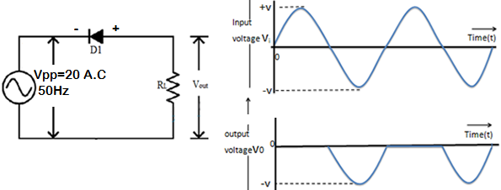

Cathode is connected to the power supply and anode is maintained at ground potential.

* **During Positive Half Cycle:** Output voltage (VO) = 0 Volts
* **During Negative Half Cycle:** Output voltage (VO) = (Vin + Vd) Volts

Where Vd is the Diode Threshold Voltage.

**(b)- Series Negative Clipper**

A series negative clipper is basically a half wave rectifier circuit. Consider a circuit shown in the Fig. Where diode is connected in series with the load. Let us analyze this circuit. For a positive half cycle, the diode D1 is forward biased. Hence the voltage waveform across RLlooks like a positive half cycle of the input voltage.

While for a negative half cycle, diode D1 is reverse biased and hence will not conduct at all. Hence there will not be any voltage available across resistance RL. Hence the negative half cycle of input voltage gets clipped off. The input waveform and the corresponding output voltage waveform is shown in the Fig.

For an ideal diode, the output voltage will reach to the same maximum level as that of input, during positive half cycle.

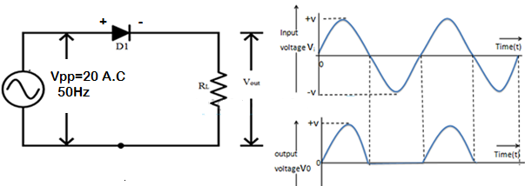

Anode is connected to the power supply and the cathode is maintained at ground potential.

* **During Positive Half Cycle:** Output voltage (VO) = (Vin – Vd) Volts
* **During Negative Half Cycle:** Output voltage (VO) = 0 Volts

**PROCEDURE:**

1. Set up the circuit one by one after testing the components. Apply 20V peak to peak sine at the input.
2. Observe the input & output waveforms simultaneously on the CRO screen keeping AC-DC switch of the CRO in DC position.
3. Note the values & plot the waveform.

**RESULT- ……………………………………………………………..**

**(B)-CLAMPING CIRCUITS**

**AIM: To Study various clamping circuits using diodes.**

**APPARATUS REQUIRED:**

|  |  |  |  |
| --- | --- | --- | --- |
| S.NO. | Name of the Apparatus | Range | Quantity |
| 1 | Bread Board | - | 1 |
| 2 | Capacitor | 1µF | 1 |
| 3 | DC source | 3 V | 1 |
| 4 | Si Diode | 1N4007 | 1 |
| 5 | C.R.O./D.S.O. | - | 1 |
| 6 | Wire | - | 6 |
| 7 | Function Generator/AC Power supply | - | 1 |

**THEORY:**

In some situations, it is necessary to add or subtract a dc voltage to a given waveform without changing its shape. Circuits used for this purpose are called clamping circuits. This can be achieved by connecting a dc source in series with the input. DC sources are very expensive and bulky equipment’s. A capacitor which is charged to a voltage & subsequently prevented from discharging can serve as a suitable replacement for a dc source. This principle is utilized in clamping circuits. The clamping level can be made at any voltage level by biasing the diode. Such a clamping circuit is called a biased clamper.

**(A)-Positive clamper clamping at 0 V:**

Suppose the input voltage is represented by theexpression VmSin*w*t. During one negative half cycle of the input sine wave, the diode conducts and the capacitor charges to Vm with positive polarity at the right side of the capacitor. During the positive half of the input sine wave, the capacitor cannot discharge since the diode does not conduct. Thus capacitor acts as a dc source of Vm volts in series with input signal source. The output voltage then can be expressed as Vo = Vm + VmSin*w*t

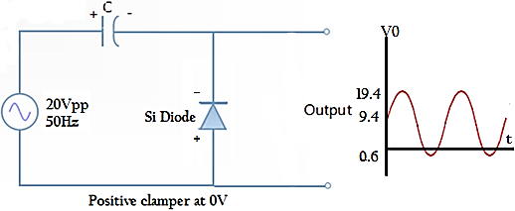

**(B)-Negative clamper clamping at 0 V:**

Suppose the input voltage is represented by theexpression VmSin*w*t. During one positive half cycle of the input sine wave, the diode conducts and the capacitor charges to Vm with positive polarity at the right

side of the capacitor. During the positive half of the input sine wave, the capacitor cannot discharge since the diode does not conduct. Thus capacitor acts as a dc source of Vm volts in series with input signal source. The output voltage then can be expressed as Vo = - Vm + VmSin*w*t

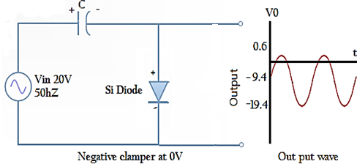

**(C)-Positive clamper clamping at + 3V:**

During one negative half cycle of the inputsine wave, capacitor charges through the dc source and diode till ( Vm + 3) volts with positive polarity of the capacitor at its right side. The charging of the capacitor is limited to (Vm + 3) volts due to the presence of the dc source. The output is then expressed as Vo = (Vm + 3) + VmSin*w*t

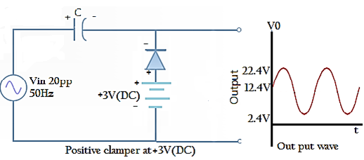

**(D)-Negative clamper clamping at + 3V:**

During one positive half cycle of the inputsine wave, capacitor charges through the dc source and diode till ( Vm - 3) volts with negative polarity of the capacitor at its right side. The charging of the capacitor is limited to (Vm - 3) volts due to the presence of the dc source. The output is then expressed as Vo = -(Vm - 3) + V mSin*w*t

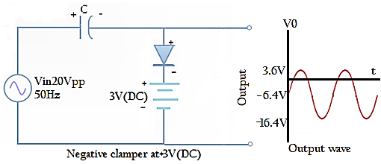

**PROCEDURE:**

* + 1. Set up the circuit one by one after testing the components. Apply 20V peak to peak sine at the input.
    2. Observe the input & output waveforms simultaneously on the CRO screen keeping AC-DC switch of the CRO in DC position.
    3. Note the values & plot the waveform.

**RESULT- …………………………………………………………………**

**EXPERIMENT NO-5**

**STUDY OF TRANSISTOR CHARACTERISTICS COMMON EMITTER (NPN) OR (PNP).**

**:**

## AIM: Study of the characteristics of NPN transistor in common emitter configuration and to evaluate:

**1. Input resistance**

**2. Output resistance**

**3. Current gain**

## MATERIAL REQUIREDS:

**1.** Analog board of **AB04.**

**2.** DC power supplies +12V, +5V from **Analog lab** board

**3.** Digital Multi meter (2numbers).

**4.** 2 mm patch cords (connecting wire)

## THEORY:

Input Characteristic**:** In common emitter configuration, it is the curve plotted between the input current (IB) verses input voltage (VBE) for various constant values of output voltage (VCE).

This characteristic reveal that for fixed value of output voltage VCE, as the base to emitter voltage increases, the emitter current increases in a manner that closely resembles the diode characteristics.

The input resistance is calculated using the formula,

## 



## Input characteristics of CE (NPN) figure 1

Output Characteristic***:*** This is the curve plotted between the output current IC verses output voltage VCE for various constant values of input current IB.

The output characteristic has three basic region of interest as indicated in figure 2 the active region, cutoff region and saturation region.

In active region the collector base junction is reverse biased while the base emitter junction if forward biased. This region is normally employed for linear (undistorted) amplifier.

In cutoff region the collector base junction and base emitter junction of the transistor both are reverse biased. In this region transistor acts as an ‘Off’ switch.

In saturation region the collector base junction and base emitter junction of the transistor both are forward biased. In this region transistor acts as an on switch.



## Output characteristics of CE (NPN) figure-2

## Constant current transfer Characteristics: This is the curve plotted between output collector current IC versus input base current IB for constant value of output voltage VCE.

The approximated plot for this characteristic is shown in figure 3.



## Constant current transfer characteristics of CE (NPN) figure 3

## PROCEDURE:

 • Connect +5V and +12V DC power supplies at their indicated position from external source or Analog lab board

## To plot input characteristics proceed as follows:

**1.** Rotate both the potentiometer P1 and P2 fully in CCW (counter clockwise direction).

**2.** Connect Ammeter between test point 2 and 3 to measure input base current IB(A).

**3.** Short or connect a 2mm patch cord between test point 4 and 5.

**4.** Connect one voltmeter between test point 1 and ground to measure input voltage

VBE other voltmeter between test point 6 and ground to measure output voltage VCE.

**5.** Switch ‘On’ the power supply.

**6.** Vary potentiometer P2 and set a value of output voltage VCE at some constant value (1V, 3V...)

**7.** Vary the potentiometer P1 so as to increase the value of input voltage VBE from zero to 0.8V in step and measure the corresponding values of input current IB for different constant value of output voltage VCE in an observation Table 1.

**8.** Rotate potentiometer P1 fully in CCW direction.

**9.** Repeat the procedure from step 6 for different sets of output voltage VCE.

**10.** Plot a curve between input voltage VBE and input current IB as shown in figure 1 using suitable scale with the help of Observation Table l. This curve is the required input characteristic.

## • To plot output characteristics proceed as follows:

**1.** Switch ‘Off’ the power supply.

**2.** Rotate both the potentiometer P1 and P2 fully in CCW (counter clockwise direction).

**3.** Connect voltmeter between test point 6 and ground to measure output voltage VCE.

**4.** Connect one Ammeter between test point 2 and 3 to measure input current IB(A) and other Ammeter between test point 4 and 5 to measure output current IC(mA).

**5.** Switch ‘On’ the power supply.

**6.** Vary potentiometer P1 and set a value of input current IB at some constant value

(0A, 10A......100A)

**7.** Vary the potentiometer P2 so as to increase the value of output voltage VCE from zero to maximum value in step and measure the corresponding values of output current IC for different constant value of input current IB in an observation

table2.

**8.** Rotate potentiometer P2 fully in CCW direction.

**9.** Repeat the procedure from step 6 for different sets of input current IB.

**10.** Plot a curve between output voltage VCE and output current IC as shown in figure 2 using suitable scale with the help of Observation Table 2. This curve is the required output characteristic.

## To plot constant current transfer characteristics proceed as follows:

1. Switch ‘Off’ the power supply.

2. Rotate both the potentiometer P1 and P2 fully in CCW (counter clockwise direction).

3. Connect voltmeter between test point 6 and ground to measure output voltage VCE.

4. Connect one Ammeter between test point 2 and 3 to measure input current IB

(mA) and other Ammeter between test point 4 and 5 to measure output current IC (mA).

5. Switch ‘On’ the power supply.

6. Vary potentiometer P2 and set a value of output voltage VCE at maximum value.

7. Vary the potentiometer P1 so as to increase the value of input current IB from zero to 10mA in step and measure the corresponding values of output current IC in an Observation Table 3.

8. Plot a curve between output current IC and input current IB as shown in figure 3 using suitable scale with the help of observation Table 3. This curve is the required Transfer characteristic.

## OBSERVATION: For input characteristics-

|  |  |  |  |  |
| --- | --- | --- | --- | --- |
| S.NO. | Input voltage  VBE | Input current IB(A) at constant value of output voltage | | |
| VCE=1V | VCE=3V | VCE=5V |
| 1 | 0.0 |  |  |  |
| 2 | 0.1 |  |  |  |
| 3 | 0.2 |  |  |  |
| 4 | 0.3 |  |  |  |
| 5 | 0.4 |  |  |  |
| 6 | 0.5 |  |  |  |
| 7 | 0.6 |  |  |  |
| 8 | 0.7 |  |  |  |
| 9 | 0.8 |  |  |  |

For output characteristics-

|  |  |  |  |  |  |  |
| --- | --- | --- | --- | --- | --- | --- |
| S.NO. | Output voltage  VCE | Output current Ic (mA) at constant value of Input current | | | | |
| IB=0A | IB=10A | IB=20A | IB=30A | IB=40A |
| 1. | 0.5 |  |  |  |  |  |
| 2. | 1.0 |  |  |  |  |  |
| 3. | 2.0 |  |  |  |  |  |
| 4. | 3.0 |  |  |  |  |  |
| 5. | 4.0 |  |  |  |  |  |
| 6. | 5.0 |  |  |  |  |  |
| 7. | 6.0 |  |  |  |  |  |
| 8. | 7.0 |  |  |  |  |  |
| 9. | 8.0 |  |  |  |  |  |
| 10. | 9.0 |  |  |  |  |  |

For constant current transfer characteristics-

|  |  |  |
| --- | --- | --- |
| S.NO. | Input current IB(A) | Output current IC (mA) at constant output voltage  VCE. = maximum |
| 1. | 00.0 |  |
| 2. | 10.0 |  |
| 3. | 20.0 |  |
| 4. | 30.0 |  |
| 5. | 40.0 |  |
| 6. | 50.0 |  |
| 7. | 60.0 |  |
| 8. | 70.0 |  |
| 9. | 80.0 |  |
| 10. | 90.0 |  |
| 11. | 100.0 |  |

# RESULT: Thus the characteristics of Transistor (NPN ) in common emitter configuration has been verified and the graph has been plotted according to the observation and to evaluate-

1. Input resistance 2. Output resistance3. Current gain

## AIM:****Study of the characteristics of PNP transistor in common emitter configuration and to evaluate****

**1. Input resistance**

**2. Output resistance**

**3. Current gain**

## MATERIAL REQUIREDS:

**1. Analog board of AB05.**

**2. DC power supplies -12V, -5V from Analog lab board.**

**3. Digital Multi meter (2numbers).**

**4. 2 mm patch cords connecting wire.**

## Input Characteristic: **In common emitter configuration, it is the curve plotted between the input current** **versus input voltage (****) for various constant values of output voltage (****).**

**The approximated plot for input characteristic is shown in figure 1. This characteristic reveals that for fixed value of output voltage VEC, as the base to emitter voltage increases, the emitter current increases in a manner that closely resembles the diode characteristics.**



Input characteristics of CE (PNP) figure 1

## Output Characteristic:**This is the curve plotted between the output current IC versus output voltage VEC for various constant values of input current IB.**

**The output characteristic has three basic region of interest as indicated in figure 2 the active region, cutoff region and saturation region.**

**In active region the collector base junction is reverse biased while the base emitter junction is forward biased. This region is normally employed for linear (undistorted) amplifier.**

**In cutoff region the collector base junction and base emitter junction of the transistor both are reverse biased. In this region transistor acts as an ‘Off’ switch.**

**In saturation region the collector base junction and base emitter junction of the transistor both are forward biased. In this region transistor acts as an ‘On’ switch**.



**Output characteristics of CE (PNP) figure -2**

## Constant current transfer Characteristics:**This is the curve plotted between output collector current $I_{c}$ versus input base current $I_{B}$ for constant value of output voltage $V_{CE}$.**

**The approximated plot for this characteristic is shown in figure 3.**



## Constant current transfer characteristics of CE (PNP) figure -3

## PROCEDURE:

**Connect -5V and -12V DC power supplies at their indicated position from external source or ST2612 Analog Lab.**

## To plot input characteristics proceed as follows:

**1. Rotate both the potentiometer P1 and P2 fully in CCW (counter clockwise direction).**

**2. Connect Ammeter between test point 2 and 3 to measure input base current IB (A).**

**3. Short or connect a 2mm patch cord between test point 4 and 5**

**4. Connect one voltmeter between test point 1 and ground to measure input voltage VBE and another voltmeter between test point 6 and ground to measure output voltage VEC.**

**5. Switch ‘On’ the power supply.**

**6. Vary potentiometer P2 and set a value of output voltage VEC at some constant value (1V, 3V,)**

**7. Vary the potentiometer P1 so as to increase the value of input voltage VEB from zero to 0.8V in step and measure the corresponding values of input current IB for different constant value of output voltage VEC in an observation Table 1.**

**8. Rotate potentiometer P1 fully in CCW direction.**

**9. Repeat the procedure from step 6 for different sets of output voltage VEC.**

**10. Plot a curve between input voltages VEB and input current IB as shown in figure 1 using suitable scale with the help of observation Table l. This curve is the required input characteristic.**

## **· To plot output characteristics proceed as follows:**

**1. Switch ‘Off’ the power supply.**

**2. Rotate both the potentiometer P1 and P2 fully in CCW (counter clockwise direction).**

**3. Connect voltmeter between test point 6 and ground to measure output voltage VEC.**

**4. Connect one Ammeter between test point 2 and 3 to measure input current IB (mA) and another Ammeter between test point 4 and 5 to measure output current IC (mA).**

**5. Switch ‘On’ the power supply.**

**6. Vary potentiometer P1 and set a value of input current IB at some constant value (0mA,10mA......100mA)**

**7. Vary the potentiometer P2 so as to increase the value of output voltage VEC from zero to maximum value in step and measure the corresponding values of output current IC for different constant value of input current IB in an observation table 2.**

**8. Rotate potentiometer P2 fully in CCW direction.**

**9. Repeat the procedure from step 6 for different sets of input current IE.**

**10. Plot a curve between output voltages VEC and output current IC as shown in figure 2 using suitable scale with the help of observation table 2. This curve is the required output characteristic.**

To plotconstant current transfer characteristics proceed as follows*:*

**1. Switch ‘Off’ the power supply.**

**2. Rotate both the potentiometer P1 and P2 fully in CCW (counter clockwise direction).**

**3. Connect voltmeter between test point 6 and ground to measure output voltage VEC.**

**4. Connect one Ammeter between test point 2 and 3 to measure input current IB (mA) and other Ammeter between test point 4 and 5 to measure output current IC (mA).**

**5. Switch ‘On’ the power supply.**

**6. Vary potentiometer P2 and set a value of output voltage VEC at maximum value.**

**7. Vary the potentiometer P1 so as to increase the value of input current IB from zero to 100 (mA) in step and measure the corresponding values of output current IC (mA) in an observation Table3.**

**8. Plot a curve between output current IC and input current IB as shown in figure 3 using suitable scale with the help of observation Table 3. This curve is the required Transfer characteristic.**

## OBSERVATIONS:

## For input characteristics-

|  |  |  |  |  |
| --- | --- | --- | --- | --- |
| S.NO. | Input voltage  VBE | Input current IB (A) at constant value of output voltage | | |
| VCE=1V | VCE=3V | VCE=5V |
| 1 | 0.0 |  |  |  |
| 2 | 0.1 |  |  |  |
| 3 | 0.2 |  |  |  |
| 4 | 0.3 |  |  |  |
| 5 | 0.4 |  |  |  |
| 6 | 0.5 |  |  |  |
| 7 | 0.6 |  |  |  |
| 8 | 0.7 |  |  |  |
| 9 | 0.8 |  |  |  |
| 10 | 0.9 |  |  |  |

**For output characteristics-**

|  |  |  |  |  |  |  |
| --- | --- | --- | --- | --- | --- | --- |
| S.NO. | Output voltage  VCE | Output current IC (mA) at constant value of Input current | | | | |
| IB=0A | IB=10A | IB=20A | IB=30A | IB=40A |
| 1 | 0.5 |  |  |  |  |  |
| 2 | 1.0 |  |  |  |  |  |
| 3 | 2.0 |  |  |  |  |  |
| 4 | 3.0 |  |  |  |  |  |
| 5 | 4.0 |  |  |  |  |  |
| 6 | 5.0 |  |  |  |  |  |
| 7 | 6.0 |  |  |  |  |  |
| 8 | 7.0 |  |  |  |  |  |
| 9 | 8.0 |  |  |  |  |  |
| 10 | 9.0 |  |  |  |  |  |

For constant current transfer characteristics-

|  |  |  |
| --- | --- | --- |
| S.NO. | Input current  IB (A) | Output current IC (mA) at constant value of output voltage  VCE. = maximum |
| 1 | 0.0 |  |
| 2 | 1.0 |  |
| 3 | 2.0 |  |
| 4 | 3.0 |  |
| 5 | 4.0 |  |
| 6 | 5.0 |  |
| 7 | 6.0 |  |
| 8 | 7.0 |  |
| 9 | 8.0 |  |
| 10 | 9.0 |  |

## RESULT:Thus the characteristics of Transistor (PNP ) in common emitter configuration has been verified and the graph has been plotted according to the observation and to evaluated

1. Input resistance 2. Output resistance 3. Current gain

**EXPERIMENT NO-6**

**STUDY OF TRANSISTOR CHARACTERISTICS COMMON BASE (NPN) OR (PNP)**

## AIM:Study the characteristics of NPN transistor in common base configuration and to evaluate

**1. Input resistance**

**2. Output resistance**

**3. Current gain**

MATERIAL REQUIREDS**:**

**1.** Analog board of **AB02.**

**2.** DC power supplies +12V, -5V from **Analog lab board**

**3.** Digital Multi meter (2numbers).

**4.** 2 mm patch cords.

## THEORY:A Transistor is three terminal active device. The three terminals are emitter, base & collector. In common base configuration, we make the base common to both input & output.

## Input Characteristic:In common base configuration, it is the curve plotted between the input current (IE) versus input voltage () for various constant values of output voltage (VCB).

This characteristic is very similar to that of a forward-biased diode characteristics. The input resistance is calculated using the formula

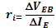



## Input characteristics of CB (NPN) figure -1

Output Characteristic***:*** This is the curve plotted between the output current IC versus output voltage VCB for various constant values of input current IE. These curves are almost horizontal. This shows that the output dynamic resistance is very high,

# 



*Output characteristics of CB (NPN) figure 2*

## Constant current transfer Characteristic: This is the curve plotted between output collector current IC versus input emitter current IE for constant value of output voltage VCB.



## Constant current transfer characteristics CB (NPN) figure 3

## PROCEDURE:

• Connect -5V and +12V DC power supplies at their indicated position from external source or **Analog lab board.**

## To plot input characteristics proceed as follows:

**1.** Rotate both the potentiometer P1 and P2 fully in CCW (counter clockwise direction).

**2.** Connect Ammeter between test point 2 and 3 to measure input emitter current IE (mA)

**3.** Short or connect a 2mm patch cord between test point 4 and 5

**4.** Connect one voltmeter between test point 1 and ground to measure input voltage,

VBE other voltmeter between test point 6 and ground to measure output voltage VCB.

**5.** Switch ‘On’ the power supply.

**6.** Vary potentiometer P2 and set a value of output voltage VCB at some constant value (1V, 2V…)

**7.** Vary the potentiometer P1 so as to increase the value of input voltage VBE from zero to 0.9V in step and measure the corresponding values of input current IE for different constant value of output voltage VCB in an observation Table 1.

**8.** Rotate potentiometer P1 fully in CCW direction.

**9.** Repeat the procedure from step 6 for different sets of output voltage VCB.

**10.** Plot a curve between input voltages VBE and input current IE as shown in figure 1 using suitable scale with the help of observation Table l. This curve is the required input characteristic.

## To plot output characteristics proceed as follows:

**1.** Switch ‘Off’ the power supply.

**2.** Rotate both the potentiometer P1 and P2 fully in CCW (counterclockwise direction).

**3.** Connect voltmeter between test point 6 and ground to measure output voltage VCB.

**4.** Connect one Ammeter between test point 2 and 3 to measure input current IE (mA) and other Ammeter between test point 4 and 5 to measure output current IC (mA).

**5.** Switch ‘On’ the power supply.

**6.** Vary potentiometer P1 and set a value of input current IE at some constant value

(0mA, 1mA...)

**7.** Vary the potentiometer P2 so as to increase the value of output voltage VCB from zero to maximum value in step and measure the corresponding values of output current IC for different constant value of input current IE in an observation Table 2.

**8.** Rotate potentiometer P2 fully in CCW direction.

**9.** Repeat the procedure from step 6 for different sets of input current IE.

**10.** Plot a curve between output voltage VCB and output current IC as shown in figure 2 using suitable scale with the help of observation Table 2. This curve is the required output characteristic.

## To plot constant current transfer characteristics proceed as follows:

**1.** Switch ‘Off’ the power supply.

**2.** Rotate both the potentiometer P1 and P2 fully in CCW (counter clockwise direction).

**3.** Connect voltmeter between test point 6 and ground to measure output voltage VCB.

**4.** Connect one Ammeter between test point 2 and 3 to measure input current IE

(mA) and other Ammeter between test point 4 and 5 to measure output current IC (mA).

**5.** Switch ‘On’ the power supply.

**6.** Vary potentiometer P2 and set a value of output voltage VCB at maximum value.

**7.** Vary the potentiometer P1 so as to increase the value of input current IE from zero to 10 mA in step and measure the corresponding values of output current IC in an observation Table 3.

**8.** Plot a curve between output current IC and input current IE as shown in figure 3using suitable scale with the help of observation Table 3. This curve is the required Transfer characteristic.

## OBSERVATION:

## For input characteristics-

|  |  |  |  |  |
| --- | --- | --- | --- | --- |
| S.NO. | Input voltage VEB | Input current IE (mA) at constant value of output voltage | | |
|  |  | VCB=1V | VCB=3V | VCB=5V |
| 1. | 0.0 |  |  |  |
| 2. | 0.1 |  |  |  |
| 3. | 0.2 |  |  |  |
| 4. | 0.3 |  |  |  |
| 5. | 0.4 |  |  |  |
| 6. | 0.5 |  |  |  |
| 7. | 0.6 |  |  |  |
| 8. | 0.7 |  |  |  |
| 9. | 0.8 |  |  |  |
| 10. | 0.9 |  |  |  |

**For output characteristics-**

|  |  |  |  |  |  |  |
| --- | --- | --- | --- | --- | --- | --- |
| S.NO. | Output voltage  VCB | Output current Ic (mA) at constant value of Input current | | | | |
| IE=0mA | IE=1mA | IE=2mA | IE=3mA | IE=4mA |
| 1. | 0.0 |  |  |  |  |  |
| 2. | -1.0 |  |  |  |  |  |
| 3. | 0.5 |  |  |  |  |  |
| 4. | 1.0 |  |  |  |  |  |
| 5. | 2.0 |  |  |  |  |  |
| 6. | 3.0 |  |  |  |  |  |
| 7. | 4.0 |  |  |  |  |  |
| 8. | 5.0 |  |  |  |  |  |
| 9. | 6.0 |  |  |  |  |  |
| 10. | 7.0 |  |  |  |  |  |

**For constant current transfer characteristics-**

|  |  |  |
| --- | --- | --- |
| S.NO. | Input current  IE (mA) | Output current Ic (mA) at constant output voltage  Vcb=maximum |
| 1. | 0.0 |  |
| 2. | 1.0 |  |
| 3. | 2.0 |  |
| 4. | 3.0 |  |
| 5. | 4.0 |  |
| 6. | 5.0 |  |
| 7. | 6.0 |  |
| 8. | 7.0 |  |
| 9. | 8.0 |  |
| 10. | 9.0 |  |

## RESULT: Thus the characteristics of Transistor (NPN ) in common base configuration has been verified and the graph has been plotted according to the observation and to evaluate-

1. Input resistance

2. Output resistance

3. Current gain

**(B)-Study of the characteristics of PNP transistor in common base configuration**

## AIM: Study of the characteristics of PNP transistor in common base configuration and to evaluation of –

**1. Input resistance**

**2. Output resistance**

**3. Current gain**

## MATERIAL REQUIREDS:

**1.** Analog board of **AB03.**

**2.** DC power supplies-12V, +5V from **Analog lab board**

**3.** Digital Multi meter (3 numbers).

**4.** 2 mm patch cords.

## THEORY:

Input Characteristic***:*** In common base configuration, it is the curve plotted between the input current (IE) verses input voltage (VEB) for various constant values of output voltage (VBC).

The approximated plot for input characteristic is shown in figure 1. This characteristic reveals that for fixed value of output voltage VBC, as the base to emitter voltage increases, the emitter current increases in a manner that closely resembles the diode characteristics.



## Input characteristics of CB (PNP) figure -1

## Output Characteristic: This is the curve plotted between the output current IC verses output voltage VBC for various constant values of input current IE.

The output characteristic has three basic region of interest as indicated in Figure.2 the active region, cutoff region and saturation region.

In active region the collector base junction is reverse biased while the base emitter junction if forward biased. This region is normally employed for linear (undistorted) amplifier.

In cutoff region the collector base junction and base emitter junction of the transistor both are reverse biased. In this region transistor acts as an ‘Off’ switch.

In saturation region the collector base junction and base emitter junction of the transistor both are forward biased. In this region transistor acts as an ‘On’ switch.



Output characteristics of CB (PNP) figure -2

## Constant current transfer Characteristic:This is the curve plotted between output collector current IC verses input emitter current IE for constant value of output voltage VBC.

The approximated plot for this characteristic is shown in figure 3.



## Constant current transfer characteristics of CB (PNP) figure -3

PROCEDURE***:***

Connect +5V and -12V DC power supplies at their indicated position from external source or **Analog lab board**

## To plot input characteristics proceed as follows:

**1.** Rotate both the potentiometer P1 and P2 fully in CCW (counter clockwise direction).

**2.** Connect Ammeter between test point 2 and 3 to measure input emitter current IE (mA).

**3.** Short or connect a 2mm patch cord between test point 4 and 2

**4.** Connect one voltmeter between test point 1 and ground to measure input voltage

VEB other voltmeter between test point 6 and ground to measure output voltage VBC.

**5.** Switch ‘On’ the power supply.

**6.** Vary potentiometer P2 and set a value of output voltage VBC at some constant value (1V, 2V)

**7.** Vary the potentiometer P1 so as to increase the value of input voltage VEB from zero to 0.9V in step and measure the corresponding values of input current IE for different constant value of output voltage VBC in an observation Table 1.

**8.** Rotate potentiometer P1 fully in CCW direction.

**9.** Repeat the procedure from step 6 for different sets of output voltage VBC.

**10.** Plot a curve between input voltages VEB and input current IE as shown in Figure.1 using suitable scale with the help of observation Table l. This curve is the required input characteristic.

## To plot output characteristics proceed as follows:

**1.** Switch ‘Off’ the power supply.

**2.** Rotate both the potentiometer P1 and P2 fully in CCW (counterclockwise direction).

**3.** Connect voltmeter between test point 6 and ground to measure output voltage VBC.

**4.** Connect one Ammeter between test point 2 and 3 to measure input current IE (mA) and other Ammeter between test point 4 and 5 to measure output current IC (mA).

**5.** Switch ‘On’ the power supply.

**6.** Vary potentiometer P1 and set a value of input current IE at some constant value

(0mA, 1mA...)

**7.** Vary the potentiometer P2 so as to increase the value of output voltage VBC from zero to maximum value in step and measure the corresponding values of output current IC for different constant value of input current IE in an observation Table 2.

**8.** Rotate potentiometer P2 fully in CCW direction

**9.** Repeat the procedure from step 6 for different sets of input current IE.

**10.** Plot a curve between output voltages VBC and output current IC as shown in figure 2 using suitable scale with the help of observation Table 2. This curve is the required output characteristic.

## To plot constant current transfer characteristics proceed as follows:

**1.** Switch ‘Off’ the power supply.

**2.** Rotate both the potentiometer P1 and P2 fully in CCW (counter clockwise direction).

**3.** Connect voltmeter between test point 6 and ground to measure output voltage VBC.

**4.** Connect one Ammeter between test point 2 and 3 to measure input current IE (mA) and other Ammeter between test point 4 and 5 to measure output current IC (mA).

**5.** Switch ‘On’ the power supply.

**6.** Vary potentiometer P2 and set a value of output voltage VBC at maximum value.

**7.** Vary the potentiometer P1 so as to increase the value of input current IE from zero to 10 mA in step and measure the corresponding values of output current IC in an observation Table 3.

**8.** Plot a curve between output current IC and input current IE as shown in figure 3 using suitable scale with the help of observation Table 3. This curve is the required Transfer characteristic.

## OBSERVATION: For input characteristics-

|  |  |  |  |  |
| --- | --- | --- | --- | --- |
| S. NO. | Input voltage **VEB** | Input current at constant value of output voltage | | |
| **VBC = 1V** | **VBC = 3V** | **VBC = 5V** |
| 1 | 0.0 |  |  |  |
| 2 | 0.1 |  |  |  |
| 3 | 0.2 |  |  |  |
| 4 | 0.3 |  |  |  |
| 5 | 0.4 |  |  |  |
| 6 | 0.5 |  |  |  |
| 7 | 0.6 |  |  |  |
| 8 | 0.7 |  |  |  |
| 9 | 0.8 |  |  |  |
| 10. | 0.9 |  |  |  |

Table 1

For output characteristics-

|  |  |  |  |  |  |  |
| --- | --- | --- | --- | --- | --- | --- |
| S.NO. | Output voltage **VBC** | Output current at constant value of Input current | | | | |
| **IE = 0mA** | **IE = 1mA** | **IE = 2mA** | **IE = 3mA** | **IE = 4mA** |
| 1. | -1.0 |  |  |  |  |  |
| 2. | 0.0 |  |  |  |  |  |
| 3. | 0.5 |  |  |  |  |  |
| 4. | 1.0 |  |  |  |  |  |
| 5. | 2.0 |  |  |  |  |  |
| 6. | 3.0 |  |  |  |  |  |
| 7. | 4.0 |  |  |  |  |  |
| 8. | 5.0 |  |  |  |  |  |
| 9. | 6.0 |  |  |  |  |  |
| 10. | 7.0 |  |  |  |  |  |

Table 2

For constant current transfer characteristics-

|  |  |  |
| --- | --- | --- |
| S. NO. | Input current  **IE (mA)** | Output current at constant value of output voltage |
| 1. | 0.0 |  |
| 2. | 1.0 |  |
| 3. | 2.0 |  |
| 4. | 3.0 |  |
| 5. | 4.0 |  |
| 6. | 5.0 |  |
| 7. | 6.0 |  |
| 8. | 7.0 |  |
| 9. | 8.0 |  |
| 10. | 9.0 |  |

Table 3

## RESULT: Thus the characteristics of Transistor (PNP) in common base configuration has been verified and the graph has been plotted according to the observation and evaluated-

1. Input resistance

2. Output resistance

3. Current gain

**EXPERIMENT NO-7**

**STUDY OF LOGIC GATES**

**AIM: To study about logic gates and verify their truth tables**.

**APPARATUS REQUIRED:**

|  |  |  |  |
| --- | --- | --- | --- |
| **SL No.** | **COMPONENT** | **SPECIFICATION** | **QTY** |
| 1. | AND GATE IC | IC 7408 | 1 |
| 2. | OR GATE IC | IC 7432 | 1 |
| 3. | NOT GATE IC | IC 7404 | 1 |
| 4. | NAND GATE IC | IC 7400 | 1 |
| 5. | NOR GATE IC | IC 7402 | 1 |
| 6. | X-OR GATE IC | IC 7486 | 1 |
| 9. | BREADBOARD |  | 1 |
| 7. | DIGITAL LAB TRAINER KIT | - | 1 |
| 8. | PATCH CORD | - | 6 |

**THEORY:** Circuit that takes the logical decision and the process are called logic gates. Each gate has one or more input and only one output.OR, AND & NOT are basic gates. NAND, NOR and X-OR are known as universal gates. Basic gates form these gates.

**AND GATE:** The AND gate performs a logical multiplication commonly known as AND function. The output is high when both the inputs are high. The output is low level when any one of the inputs is low.

**OR GATE:**The OR gate performs a logical addition commonly known as OR function. The output is high when any one of the inputs is high. The output is low level when both the inputs are low.

**NOT GATE:** The NOT gate is called an inverter. The output is high when the input is low. The output is low when the input is high

**NAND GATE:** The NAND gate is a contraction of AND-NOT. The output is high when both inputs are low and any one of the input is low .The output is low level when both inputs are high.

**NOR GATE:** The NOR gate is a contraction of OR-NOT. The output is high when both inputs are low. The output is low when one or both inputs are high.

**X-OR GATE:** The output is high when any one of the inputs is high. The output is low when both the inputs are low and both the inputs are high.

**PROCEDURE:**

1. Connections are given as per circuit diagram.
2. Logical inputs are given as per circuit diagram.
3. Observe the output and verify the truth table.

|  |  |  |
| --- | --- | --- |
| **AND GATE** | | |
| **SYMBOL** | **TRUTH TABLE** | **PIN DIAGRAM** |
|  | |  |  |  | | --- | --- | --- | | **Input1** | **Input2** | **Output** | | **X** | **Y** | **O** | | 0 | 0 | 0 | | 0 | 1 | 0 | | 1 | 0 | 0 | | 1 | 1 | 1 | | IC.NO.-(7408) |

|  |  |  |
| --- | --- | --- |
| **OR GATE** | | |
| **SYMBOL** | **TRUTH TABLE** | **PIN DIAGRAM** |
|  | |  |  |  | | --- | --- | --- | | **Input1** | **Input2** | **Output** | | **X** | **Y** | **O** | | 0 | 0 | 0 | | 0 | 1 | 1 | | 1 | 0 | 1 | | 1 | 1 | 1 | | IC.NO-(7432) |

|  |  |  |
| --- | --- | --- |
| **NOT GATE** | | |
| **SYMBOL** | **TRUTH TABLE** | **PIN DIAGRAM** |
|  |  | **IC NO.-(7404)** |

|  |  |  |
| --- | --- | --- |
| **NANADGATE** | | |
| **SYMBOL** | **TRUTH TABLE** | **PIN DIAGRAM** |
|  |  | IC NO.-(7400) |

|  |  |  |
| --- | --- | --- |
| **NOR GATE** | | |
| **SYMBOL** | **TRUTH TABLE** | **PIN DIAGRAM** |
|  |  | **IC.NO.(7402)** |

|  |  |  |
| --- | --- | --- |
| **XOR GATE** | | |
| **SYMBOL** | **TRUTH TABLE** | **PIN DIAGRAM** |
|  |  | **IC.NO.-(7486)** |

|  |  |  |
| --- | --- | --- |
| **XNOR GATE** | | |
| **SYMBOL** | **TRUTH TABLE** | **PIN DIAGRAM** |
|  |  | **IC.NO.-(7466)** |

RESULT: ……………………………………………………………………..

PRECAUTION and SOURCES of ERROR

1. Connect the circuit with proper polarities’ & check it with the reference circuit of the experiment.
2. Do not ‘ON’ the supply if the circuit is not completely connected.
3. Theory and procedure part of the experiment must be cleared before handling the device.
4. Do not let the circuit ‘ON’ for long time as it can burn the semiconductor and supply part of the training board.
5. Assemble the circuit in a simple way, avoid jumbling, should be easily traceable.
6. Dissemble the circuit, after the experiment is completed.
7. Ensure safety measures and be aware to prevent any hazardous situation in the lab.
8. Connect the circuit with proper polarities’ & check it with the reference circuit of the experiment.
9. Do not ‘ON’ the supply if the circuit is not completely connected.
10. Theory and procedure part of the experiment must be cleared before handling the device.
11. Do not let the circuit ‘ON’ for long time as it can burn the semiconductor and supply part of the training board.
12. Assemble the circuit in a simple way, avoid jumbling, should be easily traceable.
13. Dissemble the circuit, after the experiment is completed.
14. Ensure safety measures and be aware to prevent any hazardous situation in the lab.

**EXPERIMENT NO -8**

**IMPLEMENTATION OF BASIC GATES USING UNIVERSAL GATES**

## AIM:Implementation of AND, NOT and OR function with NAND and NOR Gate

**MATERIALS REQUIRED:**

1. Digital board with +5v & GND.

2. Digital IC (NAND & NOR)

3. Patch cords

4.Bread board

## THEORY:

## INTRODUCTION:Universal gates are the ones which can be used for implementing any gate like AND, OR and NOT, or any combination of these basic gates; NAND and NOR gates are universal gates. But there are some rules that need to be followed when implementing NAND or NOR based gates.

## NAND GATE:

## The NAND gate represents the complement of the AND operation. Its name is an abbreviation of NOT AND.

The graphic symbol for the NAND gate consists of an AND symbol with a bubble on the output, denoting that a complement operation is performed on the output of the AND gate.

The truth table and the graphic symbol of NAND gate is shown in the figure.



## The truth table clearly shows that the NAND operation is the complement of the AND.

## NOR GATE-The NOR gate represents the complement of the OR operation. Its name is an abbreviation of NOT OR.

The graphic symbol for the NOR gate consists of an OR symbol with a bubble on the output, denoting that a complement operation is performed on the output of the OR gate.

The truth table and the graphic symbol of NOR gate is shown in the figure.



## The truth table clearly shows that the NOR operation is the complement of the OR.

# Universal Gates:

A universal gate is a gate which can implement any Boolean function without need to use any other gate type.

The NAND and NOR gates are universal gates.

In practice, this is advantageous since NAND and NOR gates are economical and easier to fabricate and are the basic gates used in all IC digital logic families.

In fact, an AND gate is typically implemented as a NAND gate followed by an inverter not the other way around!!

Likewise, an OR gate is typically implemented as a NOR gate followed by an inverter not the other way around!!

# NAND Gate is a Universal Gate: To prove that any Boolean function can be implemented using only NAND gates, we will show that the AND, OR, and NOT operations can be performed using only these gates.

## Implementing an Inverter Using only NAND Gate:The figure shows two ways in which a NAND gate can be used as an inverter (NOT gate).

1. All NAND input pins connect to the input signal A gives an output A’.

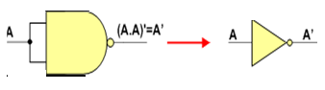

1. One NAND input pin is connected to the input signal A while all other input pins are connected to logic 1. The output will be A’.

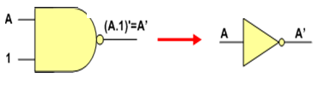

## Implementing AND Using only NAND Gate:

### An AND gate can be replaced by NAND gates as shown in the figure (The AND is replaced by a NAND gate with its output complemented by a NAND gate inverter).



## Implementing OR Using only NAND Gates:

### An OR gate can be replaced by NAND gates as shown in the figure (The OR gate is replaced by a NAND gate with all its inputs complemented by NAND gate inverters).

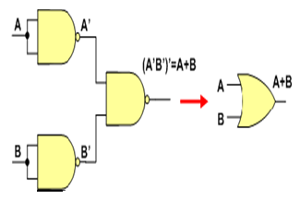

Thus, the NAND gate is a universal gate since it can implement the AND, OR and NOT functions.

# NOR Gate is a Universal Gate:

To prove that any Boolean function can be implemented using only NOR gates, we will show that the AND, OR, and NOT operations can be performed using only these gates.

Implementing an Inverter Using only NOR Gate

## The figure shows two ways in which a NOR gate can be used as an inverter (NOT gate).

1. All NOR input pins connect to the input signal A gives an output A’.

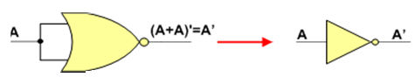

2. One NOR input pin is connected to the input signal A while all other input pins are connected to logic 0. The output will be A’.

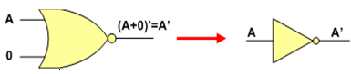

## Implementing OR Using only NOR Gates:

### An OR gate can be replaced by NOR gates as shown in the figure (The OR is replaced by a NOR gate with its output complemented by a NOR gate inverter)

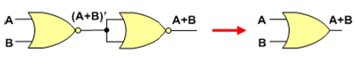

## Implementing AND Using only NOR Gates:

### An AND gate can be replaced by NOR gates as shown in the figure (The AND gate is replaced by a NOR gate with all its inputs complemented by NOR gate inverters)

A

Thus, the NOR gate is a universal gate since it can implement the AND, OR and NOT functions.

## PROCEDURE:

## 1. Connect +5 V and ground to their indicated position on DB02 from external DC

2. Power Supply or from DC power block of Digital Lab ST2611.

3. Connect inputs 00, 01, 10, 11 as per truth table to pins X and Y of OR Gate.

4. Switch on the Power Supply.

5. Observe output Z of Gate on multi meter or on logic probe or on LED display of

Digital Lab board prove truth table.

7. Repeat above steps for remaining Logic Gates.

|  |  |  |  |
| --- | --- | --- | --- |
| Table-2 | | | |
| A | B | AB’ | AB |
|  |  |  |  |
|  |  |  |  |
|  |  |  |  |
|  |  |  |  |

## OBSERVATION:

|  |  |
| --- | --- |
| Table-1 | |
| A | (A.A)’ |
|  |  |

|  |  |  |  |  |
| --- | --- | --- | --- | --- |
| Table-3 | | | | |
| A | B | A’ | B’ | (A’B’)’=A+B |
|  |  |  |  |  |
|  |  |  |  |  |
|  |  |  |  |  |
|  |  |  |  |  |

|  |  |
| --- | --- |
| Table-4 | |
| A | (A+A)’ |
|  |  |

|  |  |  |  |  |
| --- | --- | --- | --- | --- |
| Table-5 | | | | |
| A | B | A’ | B’ | (A’+B’)’=AB |
|  |  |  |  |  |
|  |  |  |  |  |
|  |  |  |  |  |
|  |  |  |  |  |

|  |  |  |  |
| --- | --- | --- | --- |
| Table-6 | | | |
| A | B | (A+B)’ | A+B |
|  |  |  |  |
|  |  |  |  |
|  |  |  |  |
|  |  |  |  |

**RESULT:………………………………………………………………………………**

**EXPERIMENT NO-9**

**ADDERS**

**(HALF ADDER & FULL ADDER)**

AIM: **Verification of Truth Table for the following Digital Circuits**

**1. 2 Bit Binary Half Adder.**

**2. 3 Bit Binary Full Adder.**

**MATERIALS REQUIRED:**

**1.** Bread Board,

**2.** DC Power Supply +5V from **Digital Lab board.**

3. Patch cords

4. 7486, 7408, 7432 IC

## THEORY:

**HALF ADDER:** The combinational circuit that performs the addition of two bits is called a Half Adder. This circuit has two binary inputs and two binary outputs. The input variable X, Y designate the augends and addend bits, the output variables Sh, Ch produces the sum and carry. The logic diagram and Truth Table are shown in experiment section.

The Boolean equation is

Sh = X’.Y +X.Y’= XY

Ch = X.Y

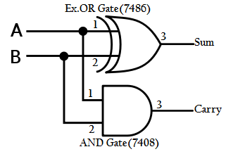

**2-bit binary half adde**r

**FULL ADDER:** The circuit that performs the addition of three bits (two significant bits and a previous carry) is called a full adder. It consists of three inputs X, Y, Z. Two of the input variable, denoted by X and Y, represents the two significant bits to be added. The third input, Z, represents the carry from the previous lower significant position. The output Sf gives the value of the least significant bit of sum and Cf gives the output carry. The logic diagram for 3-bit full adder is shown in experiment section.

The Boolean equation is

Sf = X’Y’Z + X’YZ’+ XY’Z’+ XYZ

Cf = X.Y + X.Z +Y.Z

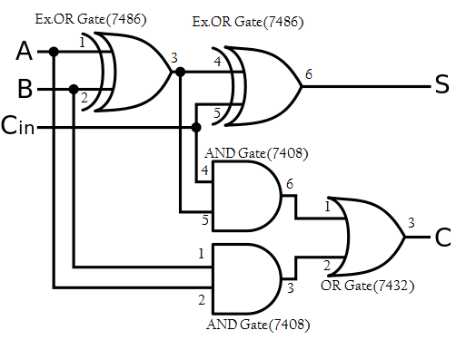

**3- Bit binary full adder**

**PROCEDURE:**

1. Connect +5 V and ground to the 14th pin and 7th pin of IC From the external DC Power Supply or from DC power block of **Digital lab board**
2. Switch on the Power Supply.
3. Connect inputs X, Y as per Truth Table to 2 bit binary Half Adder.
4. . Observe output Sh, Ch on multi meter or on LED display of **Digital Lab board** and prove Truth Table.
5. Switch Off the Power Supply.

**FULL ADDER**

1. Connect input X, Y, Z to 3 bit binary Full Adder as per Truth Table shown.
2. Observe output Sf, Cf on multi meter or on LED display of **Digital Lab board** and prove Truth Table.
3. Repeat above steps and prove Truth Table for

## OBSERVATION:

## 1. Observation table of 2- bit half adder – Table -1

|  |  |  |  |
| --- | --- | --- | --- |
| X | Y | $$C_{h}$$ | $$S_{h}$$ |
| 0 | 0 |  |  |
| 0 | 1 |  |  |
| 1 | 0 |  |  |
| 1 | 1 |  |  |

1. **Observation table of 3- bit full adder – Table – 2**

|  |  |  |  |  |
| --- | --- | --- | --- | --- |
| X | Y | Z | $$C_{f}$$ | $$S_{f}$$ |
| 0 | 0 | 0 |  |  |
| 0 | 0 | 1 |  |  |
| 0 | 1 | 0 |  |  |
| 0 | 1 | 1 |  |  |
| 1 | 0 | 0 |  |  |
| 1 | 0 | 1 |  |  |
| 1 | 1 | 0 |  |  |
| 1 | 1 | 1 |  |  |

RESULT:…………………………..

**EXPERIMENT NO -10**

**IMPLEMENTATION OF HALF AND FULL SUBSTRACTOR DIGITAL CIRCUITS.**

AIM: **Verification of Truth Table for the following Digital Circuits**

1. **Half substractor**
2. **Full substractor**

**MATERIALS REQUIRED:**

**1.** Bread Board,

**2.** DC Power Supply +5V from **Digital Lab board.**

3. Patch cords

4. 7486, 7408, 7432, 7404 IC

## THEORY:

Subtraction is the other basic function of arithmetic operations of informationprocessing tasks of digital computers. Similar to the addition function, subtraction of two binary digits consists of four possible elementary operations, which are 0–0 = 0, 0–1 = 1 with borrow of 1, 1–0 = 1, and 1–1 = 0. The first, third, and fourth operations produce a subtraction of one digit, but the second operation produces a difference bit as well as a borrow bit. The borrow bit is used for subtraction of the next higher significant bit. A combinational circuit that performs the subtraction of two bits as described above is called a half-substractor. The digit from which another digit is subtracted is called the minuend and the digit which is to be subtracted is called the subtrahend. When the minuend and subtrahend numbers contain more significant 6 digits, the borrow obtained from the subtraction of two bits is subtracted from the next higher-order pair of significant bits. Here the subtraction operation involves three bits—the minuend bit, subtrahend bit, and the borrow bit, and produces a different result as well as a borrow. The combinational circuit that performs this type of addition operation is called a full-substractor. Similar to an adder circuit, a full substractor combinational circuit can be developed by using two half-substractors. A half-substractor has two inputs and two outputs. Let the input variables minuend and subtrahend be designated as X and Y respectively, and output functions be designated as D for difference and B for borrow. The truth table of the functions is as follows.

By considering the minterms of the truth table in Figure 4, the Boolean expressions of the outputs D and B functions can be written as D = X′Y + XY′ and B = X′Y. Figure shows the logic diagram to realize the half-substractor circuit.

|  |  |  |  |
| --- | --- | --- | --- |
| **Inputs** | | **outputs** | |
| **A** | **B** | **Difference** | **borrow** |
| 0 | 0 | 0 | 0 |
| 0 | 1 | 1 | 1 |
| 1 | 0 | 1 | 0 |
| 1 | 1 | 0 | 0 |

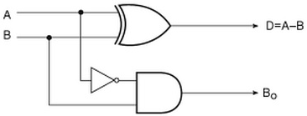

**FULL-SUBSTRACTORS** -A combinational circuit of full-substractor performs the operation of subtraction of three bits—the minuend, subtrahend, and borrow generated from the subtraction operation of previous significant digits and produces the outputs difference and borrow. Let us designate the input variables minuend as X, subtrahend as Y, and previous borrow as Z, and outputs difference as D and borrow as B. Eight different input combinations are possible for three input variables. The truth table is shown in Figure according to its functions.

|  |  |  |  |  |
| --- | --- | --- | --- | --- |
| **Inputs** | | | **Outputs** | |
| **X** | **Y** | **Z** | **Difference** | **BORROW** |
| 0 | 0 | 0 | 0 | 0 |
| 0 | 1 | 1 | 1 | 1 |
| 0 | 0 | 0 | 1 | 1 |
| 0 | 1 | 1 | 0 | 1 |
| 1 | 0 | 0 | 1 | 0 |
| 1 | 1 | 1 | 0 | 0 |
| 1 | 0 | 0 | 0 | 0 |
| 1 | 1 | 1 | 1 | 1 |

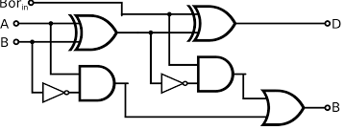

**PROCEDURE:**

1. Connect +5 V and ground to the 14th pin and 7th pin of IC From the external DC Power Supply or from DC power block of **Digital lab board**
2. Switch on the Power Supply.
3. Connect inputs X, Y as per Truth Table to 2 bit binary Half **Substractor**
4. . Observe output Sh, Ch on multi meter or on LED display of **Digital Lab board** and prove Truth Table.
5. Switch Off the Power Supply.

**Full Substractor**

1. Connect input X, Y, Z to 3 bit binary Full **Substractor** as per Truth Table shown.
2. Observe output Sf, Cf on multi meter or on LED display of **Digital Lab board** and prove Truth Table.
3. Repeat above steps and prove Truth Table for

## RESULT……….